Advances, challenges, and future perspectives of microwave reflectometry for plasma position and shape control on future nuclear fusion devices
B. Gonçalves ¹*, P. Varela ¹, A. Silva ¹, F. Silva ¹, J. Santos ¹, E. Ricardo ¹, A. Vale ¹, R. Luís ¹, Y. Nietiadi ¹, A. Malaquias ¹, J. Belo ¹, J. Dias ¹, J. Ferreira ¹ ,T. Franke ³, W. Biel ², S. Heuraux ⁴, T. Ribeiro ³ , G. De Masi ⁵, O. Tudisco ⁶, R. Cavazzana ⁵, G. Marchiori ⁵, O. D’Arcangelo ⁶
Citation: To be added by editorial staff during production.
Academic Editor: Firstname Lastname
Received: date
Accepted: date
Published: date
Publisher’s Note: MDPI stays neutral with regard to jurisdictional claims in published maps and institutional affiliations.

Copyright: © 2022 by the authors. Submitted for possible open access publication under the terms and conditions of the Creative Commons Attribution (CC BY) license (https://creativecommons.org/licenses/by/4.0/).
¹ Instituto de Plasmas e Fusão Nuclear, Instituto Superior Técnico, Universidade de Lisboa, Portugal.
² Institut für Energie- und Klimaforschung, Forschungszentrum Jülich GmbH, Germany.
³ Max-Planck-Institut für Plasmaphysik, Boltzmannstr. 2, D-85748 Garching, Germany.
⁴ Institut Jean Lamour, UMR 7198 CNRS-Université de Lorraine BP 50840, F-54011 Nancy, France.
⁵ Consorzio RFX, 35127 Padova, Italy.
⁶ Associazione EURATOM-ENEA-CR Frascati, 00044 Frascati, Italy.

* Correspondence: bruno@ipfn.tecnico.ulisboa.pt
Abstract: Providing energy from fusion and finding ways to scale up the fusion process to commercial proportions, in an efficient, economical, and environmentally benign way is one of the grand challenges for engineering. Controlling the burning plasma in real-time is one of the critical issues that need to be addressed. Plasma Position Reflectometry (PPR) is expected to have an important role in next generation fusion machines, such as DEMO, as a diagnostic to monitor the position and shape of the plasma continuously, complementing the magnetic diagnostics. The reflectometry diagnostic uses radar science methods in the microwave and millimetre wave frequency ranges and is envisaged to measure the radial edge density profile at several poloidal angles providing data for the feedback control of the plasma position and shape. While significant steps have already been given to accomplish that goal, with proof of concept tested first in ASDEX-Upgrade and afterwards in COMPASS, important ground-breaking work is still ongoing. The Divertor Test Tokamak (DTT) facility presents itself as the appropriate future fusion device to implement, develop, and test a PPR system, thus contributing to build a knowledge database in plasma position reflectometry required for its application in DEMO. At DEMO, the PPR diagnostic's in-vessel antennas and waveguides, as well as the magnetic diagnostics, may be exposed to neutron irradiation fluences $5$ to $50$ times greater than those experienced by ITER. In the event of failure of either the magnetic or microwave diagnostics, the equilibrium control of the DEMO plasma may be jeopardized. It is therefore imperative to ensure that these systems are designed in such a way that they can be replaced if necessary. To perform reflectometry measurements at the 16 envisaged poloidal locations in DEMO, plasma-facing antennas and waveguides are needed to route the microwaves between the plasma through the DEMO upper ports (UPs) to the diagnostic hall. The main integration approach for this diagnostic is to incorporate these groups of antennas and waveguides into a diagnostics slim cassette (DSC), which is a dedicated complete poloidal segment specifically designed to be integrated with the water-cooled lithium lead (WCLL) breeding blanket system. This contribution presents the multiple engineering and physics challenges addressed while designing reflectometry diagnostics using radio science techniques. Namely, short-range dedicated radars for plasma position and shape control on future fusion experiments, the advances enabled by the designs for ITER and DEMO, and the future perspectives. One key development is in the electronics, aiming at an advanced compact coherent fast frequency sweeping RF back-end [$23-100$ GHz in few $μ$s] that is being developed at IPFN-IST using commercial Monolithic Microwave Integrated Circuits (MMIC). The compactness of this back-end design is crucial for the successful integration of many measurement channels in the reduced space available in future fusion machines. Prototype tests of these devices are foreseen to be performed in current nuclear fusion machines.
Keywords: Microwave Antennas; Microwave Propagation; Millimetre Wave Propagation; Microwave Circuitry; Millimetre Wave Circuitry; Microwave Measurements, plasma diagnostic, fusion plasma.

1. Introduction
The International Thermonuclear Experimental Reactor (ITER) in France and the conceptual design of a demonstration power plant (DEMO) are advancing the development of nuclear fusion as a viable solution for large-scale energy production. In these reactors, nuclear fusion reactions occur when a deuterium and tritium (D-T) plasma is heated to temperatures ten times hotter than the core of the Sun. The position control of this extremely hot column of plasma inside the reactor’s fusion chamber, is one of the most critical issues in the operation of these power-generating devices. As such, real-time feedback control of the plasma position plays a vital role in machine protection and disruption avoidance, being crucial for successful reactor operation. However, controlling plasma parameters in future reactor-grade fusion tokamaks, like ITER and DEMO, presents significant challenges. During the ramp-up phase, it is crucial to prevent the plasma from impinging the inner vessel walls and to avoid destructive disruptions during steady-state operation. Presently, magnetic measurements are used for plasma control, but in future long pulse tokamak devices, such as ITER and DEMO, these measurements may be impacted by drifting integrators, radiation-induced voltages, or radiation damage to the magnetic pickup coils. These effects could compromise the magnetic equilibrium reconstruction, leading to premature discharge termination or damage to plasma-facing components.
Several modern measurement diagnostics used in fusion rely on Radiofrequency (RF) techniques to probe the plasma. The low amplitude of the probing waves introduces negligible perturbations to the plasma. However, the interaction between the electromagnetic (EM) field of the propagating waves and the magnetized plasma can cause changes in the amplitude, phase, polarization state, and spectrum of the waves due to propagation close to the plasma layers where cut-off reflection occurs. The location of the reflecting layers can be deduced measuring the delay caused by the round-trip of the reflected waves. This information is used to reconstruct the electron density profile, which enables the real-time location of the separatrix - the last closed magnetic surface – provided a good estimation for its density is known.
Microwave reflectometry is a radar-based technique that can be used to determine the radial distribution of plasma density in fusion experiments. This technique has been proposed as an alternative to magnetic measurements for plasma position control. The first proof of principle for reflectometry-based plasma position feedback control was successfully demonstrated on ASDEX Upgrade [1]. Microwave reflectometry is a well-proven technique in the plasma fusion community and is used for a variety of physics measurements. One application is the study of turbulence characteristics in fixed electron density layers by continuously probing the plasma with a fixed frequency wave. Other uses for microwave reflectometry can also be found in the literature [2].

2. Probing Plasmas with Microwave Reflectometry
The Maxwell equations and the motion of plasma particles induced by the EM waves can be used to describe the propagation of EM waves in an inhomogeneous medium, like a fusion plasma. This description is possible if we assume [3] that: First, when there are no EM perturbations, the plasma particles remain in their equilibrium positions (known as the cold plasma approximation). Second, the plasma is treated as a two-fluid medium consisting of ions and electrons that are coupled through the EM field of the wave (known as the fluid approximation). Third, it is considered that only the electrons contribute to the medium polarisation because the frequency of the EM waves is much higher than the eigen ion plasma frequencies, cyclotron $f_{ci}$ and ion plasma $f_{pi}$ frequencies (high-frequency approximation). Lastly, the plasma is considered homogeneous in all directions except for the direction of wave propagation (known as the slab approximation). This approach allows for a comprehensive understanding of the behaviour of EM waves in fusion plasma.
If the former approximations are assumed for a wave propagation direction perpendicular to the plasma magnetic field ($k⊥B)$, where $k$ is the propagation direction and $B$ is the plasma magnetic field, two propagation modes can be identified [4]: the ordinary mode (O-mode), where the wave’s electric field is parallel to the plasma magnetic field ($E∥B$), as illustrated in Figure 1, and the extraordinary mode (X-mode), where the electric field of the wave is perpendicular to the magnetic field of the plasma ($E⊥B$). For the case of a tokamak plasma, the poloidal component is negligible when compared to the toroidal component ($B_{φ}≫B_{θ}$) and therefore, only the toroidal component of the magnetic field is considered, i.e., $B≃B_{φ}$.
The refractive index, $N_{O}$, for an O-mode wave with frequency $f$ is described by [5]:
$$N_{O}={\left[1-{\left({f_{pe}}/f\right)}^{2}\right]}^{1/2}={\left[1-{n_{e}}/{n_{co}}\right]}^{1/2}$$ | (1)
where $n_{e}$ is the electron density and $f_{pe}={(1/2π)\left({n_{e}e^{2}}/{ϵ_{0}m_{e}}\right)}^{1/2}$ is the electron plasma frequency. Wave propagation can occur for $f>f_{pe}$ or for $n_{e}<n_{co}$, with the cut-off density given by:
$$n_{co}={\left({2πf}/e\right)}^{2}ϵ_{0}m_{e}$$ | (2)
where $e$ is the electron charge, $m_{e}$ is the electron mass and $ϵ_{0}$ is the permittivity of free space.
Figure 1. Schematic view of the O-mode reflectometry set-up where the wave electric field is not perfect aligned with the tokamak magnetic field.
A microwave reflectometer is a short-range radar dedicated to the plasma measurement: a wave with frequency $f$ is launched at normal incidence into the plasma, propagating through it until it reaches the cut-off layer with density $n_{co}(f)$, for O-mode polarization, where the refractive index becomes zero and the wave is reflected. The position of the density layers, at which the corresponding reflections occur, can be obtained by sweeping the frequency of the incident probing waves, and measuring the waves’ group delay due to the round trip from the launching antenna to the plasma and back to the receiving antenna. This information plus an initial cut-off position for the lowest probing frequency can then be used to calculate the plasma density profile along the reflectometer’s line-of-sight (LOS). Frequency-modulated continuous wave (FMCW) reflectometry using ordinary (O-mode) plasma waves can measure the radial electron density profile independently of any parameters other than the plasma density ($n_{e}$), since O-mode propagation depends solely on the electron density distribution. For that reason, reflectometry measurements have been proposed on ITER, to complement the standard magnetic measurements that are used in present machines for plasma position control [6], during the steady state operation periods. In addition, the reflectometry diagnostic displays significant advantages, namely its minimum access requirements and compatibility with the harsh environment of a fusion device plus the capability to perform density profile measurements in a short time scale (on the order of a few µs) inherent to a radar technique. Although for control purposes, measurements of the edge density profile are not an identical replacement for magnetic measurements, under certain conditions, they can provide similar capabilities [7]. In current fusion devices, position control is accomplished changing the currents in the poloidal field coils based on the real-time estimation of the plasma shape and in particular, the estimation of the plasma magnetic separatrix. Because the separatrix results exclusively from the reconstruction of the magnetic flux distribution, there is no direct relation with the electron density. Thus, a good estimation for the density just inside this flux surface is needed to track the gap between the separatrix and the vessel first-wall using a radial density profile given by reflectometry. A fusion plasma is a turbulent medium and obtaining reliable measurements from waves propagating in it has proved to be a difficult and complex task. Before considering this technique as a reliable alternative for measuring plasma position multiple challenges must be addressed. This article outlines the necessary advancements required to integrate this radar-like technique into the control systems of a fusion machine.

3. Demonstration of the PPR principle at ASDEX-Upgrade
The use microwave reflectometry for position control was successfully demonstrated for the first time on the ASDEX Upgrade (AUG) tokamak [1]. To control of the plasma column position, the location of the outer plasma boundary was tracked in real-time (RT) using a custom built very high bandwidth streaming data acquisition system [8], an optimised digital signal processing analysis and a dedicated neural-network based profile reconstruction algorithm [9]. The approach combined the RT reflectometry edge profile and a RT scaled line integrated density measurement from interferometry. After the first successful demonstration of plasma position control using reflectometry, the diagnostic’s hardware was updated to acquire a higher number of signals and to improve its RT data-acquisition and data-processing capabilities. The improvements were aimed at producing a second demonstration of a plasma position control using both AUG’s equatorial reflectometers, probing the tokamak high (HFS) and low field sides (LFS) simultaneously. This upgrade also aimed to achieve a fourfold increase of the system RT measurement rate ($25$ $μ$s cycle) and to integrate the RT reflectometry diagnostic in the AUG’s Discharge Control System (DCS), a solution closer to ITER’s PPR foreseen operation mode [10]. Both successful position control demonstrations were performed in ITER relevant plasma regimes and configurations providing a decisive contribution for the design of future PPR control systems.
The AUG broadband reflectometry diagnostic started operation in the beginning of the 1990’s. The system was designed by IPFN/IST researchers and is also operated by researchers from the research unit in close collaboration with AUG Team, of the Max-Planck Institut für Plasmaphysik (IPP). For the plasma position control experiments were used two FMCW O-mode reflectometry systems [11] to probe the plasma, installed at the tokamak equatorial plane, from the high (inner) and low (outer) magnetic field sides (HFS and LFS, respectively) of the device (see Figure 2). The HFS reflectometers operate in the $18-75$ GHz frequency range, using bands K ($18-26.5$ GHz), Ka ($26.5-40$ GHz), Q ($33-50$ GHz) and V ($50-75$ GHz). In the LFS, this range extended, up to $∼110$ GHz, with an additional reflectometer operating in the W band ($75-110$ GHz). In the LFS, two additional channels operating in X-mode used to cover the $35-75$ GHz range (using bands Q and V). The original system design was heavily influenced by the limited space available within the tokamak to route the waveguides and position the antennas behind the vessel heat shield. This shield, consisting of heat-resistant tiles, protects the inner vessel walls and plasma-facing components. The constraints, along with the experience with reflectometers built to the old ASDEX tokamak, resulted in an optimized design using mono-static focused hog-horn antennas (emission and reception is made using a single antenna). This configuration allows for a more compact solution, especially in the HFS region where space is more restricted. The higher frequency bands, V and W, which probe plasma layers further away from the antennas, were later improved to increase the system's Signal to Noise Ratio (SNR) by implementing a heterodyne detection scheme with a phase-locked-loop (PLL) and a second oscillator to drive a harmonic mixer to down-convert the reflected signals to an intermediate frequency (IF). In these channels, the IF signal is still detected with a Schottky-diode detector at approximately 1 GHz. Due to its design, the AUG reflectometry system remains the only broadband diagnostic worldwide capable of directly probing the plasma from the machine's HFS.
Figure 2. Simplified view of an ASDEX Upgrade cross-section, showing the magnetic separatrix position the points used ($R_{in}$, $R_{out}$, $Z_{I}$) for the plasma position and the lines-of-sight of the HFS and LFS microwave reflectometers.
The usual method for controlling the position of the plasma column is to monitor the location of a few specific control points of the magnetic separatrix (green line on the plot of Figure 2). Then, the position controller changes the configuration of the magnetic fields that confines the plasma on the estimation of their locations ($R_{in}, R_{out},Z_{I}$). For reflectometry to serve as a replacement for magnetic diagnostics, it must provide the controller with the same input information accurately, within a $1$ cm error bar. In the position feedback control demonstrations performed at AUG, reflectometry provided RT estimates for $R_{in}$ and $R_{out}$, while $Z_{I}$ remained magnetics based. The developed systems and real-time algorithms' performance was evaluated by conducting dedicated discharges, where the magnetic and reflectometry-based controllers were switched. The controller demonstrated its ability to handle transitions between the two input sources (magnetic and reflectometric) and maintained the controlled position close to the programmed trajectories throughout the process. During the demonstration of plasma position control using both HFS and LFS reflectometers, the estimates of the inner, $R_{in}$, and outer, $R_{out}$, separatrix positions were combined to estimate the geometric plasma radius, $R_{geo}=(R_{in}+R_{out})/2$, that replaced the corresponding input magnetic measurement in the position controller.
Figure 3 shows the main time evolution of the measured parameters of one of the four discharges used in the demonstration. The top plot shows the line integrated density (H-1) at the equatorial plane, Deuterium (D) fuelling, neutral beam (NBI), ECRH heating power, and plasma current ($I_{pa}$). During the ELMy H-mode flat-top phase, the position control switched to the reflectometry-based controller from $t∼2.6$ s until $t∼7.6$ s. After that moment the ramp down of the plasma is performed by the magnetic controller. For the period where reflectometry was used to control the plasma, the geometric radius of the plasma column was programmed (CTRL trace on the bottom plot of Figure 3) to swing $1.5$ cm (non-symmetrically) around its original position. The reflectometry-based controller maintained the reflectometry’s $R_{geo}$ within $∼±0.5$ cm of the target trajectory. The reflectometry estimates for $R_{in}$, $R_{out}$, and $R_{geo}$ are coherent with their magnetic counterparts, demonstrating very good precision although with improvable accuracy: $∼1.5$ cm and $∼2$ cm offsets to the magnetics at the LFS and HFS, respectively. The corresponding $R_{geo}$ input offset was successfully handled by the position controller when switching to and from reflectometry input at $t∼2.6$ s and $t∼7.6$ s. Similarly to the original LFS-only demonstration, in these experiments the system operated flawlessly during the programmed reflectometry control phases and its performance was reproducible in all four discharges.
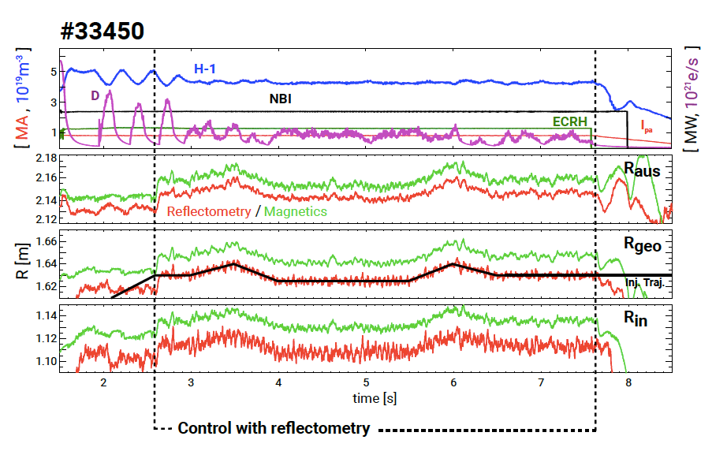
Figure 3. Time traces during an ASDEX Upgrade discharge showing the position controller target trajectory and the magnetic and reflectometric separatrix positions (the reflectometry-based control of the plasma was performed during the highlighted period).
The success of these experiments proved that it would be possible to fulfil the ITER requirements for plasma control using microwave reflectometry as an alternative to standard magnetic measurements. The use of a reflectometry-based plasma position control can contribute to achieve the high availability and reliability levels required for the operation of ITER, helping to pave the way towards the realisation of future fusion power plants.

4. On the integration of a PPR at COMPASS
The COMPASS tokamak, located in IPP-CAS Prague, is a compact divertor device that features an ITER-relevant geometry and can operate in H-mode, which makes it an ideal platform for conducting pedestal and edge physics studies relevant to ITER. COMPASS has installed a microwave reflectometer, operating in O-mode, and has a real-time control system based on the Multi-Threaded Application Real-Time executor (MARTe). These two features create optimal conditions for the further development and advanced demonstration of a reflectometry-based PPR system. To implement the PPR system at COMPASS [12], it was necessary to seamlessly integrate the microwave reflectometry diagnostic with the Real-Time Control system (RTCS) to provide the controller with robust position estimates within the allowed latency. In addition to other control tasks, the RTCS is responsible for the control of the plasma position based on standard magnetic signals.
The O-mode reflectometry diagnostic [13] probes the plasma through a quartz vacuum window located at a mid-plane LFS port. K, Ka and U microwave bands are used to probe plasma electron densities in the $0.8-4.3×{10}^{19}$ m⁻³ range. Two separate crates are used to enclose the microwave hardware and the control electronics (one for the K and Ka bands and the other for the U band). The system is also ready for an E band upgrade in the future. Each crate has a controller board, consisting of a PC/104 embedded computer with additional electronics to interface and drive the microwave oscillators. Its digital electronics are synchronised with a local high-precision $10$ MHz time-base synchronisation clock. The diagnostic can operate at fixed, hopping or swept frequency modes. The controllers allow for the remote operation of the diagnostic via the TCP/IP protocol over Ethernet, with a set of proprietary commands. The microwave electronics of each band provide the single-sideband (SSB) modulation, the in-phase (I) and the quadrature (Q) detection [14] where the SSB signal has the highest bandwidth of the set, corresponding to an IF of $48$ MHz for the K and Ka bands and $96$ MHz for the U band. The profile measurements used by the PPR system are obtained by sweeping all bands simultaneously using a configurable sweep duration; an external trigger source sets the sweep repetition rate.
Figure 4 depicts the experimental results obtained. The top picture shows the real-time reflectometry profiles. The bottom figure shows estimations of the separatrix location and magnetic radius obtained with reflectometry (blue), based on the separatrix estimation (green), and from the magnetics (red) during a control loop of $500$ $μ$s. In the case of COMPASS, the separatrix location had to be inferred from the profiles using a pre-validated fixed density representative of the plasma regime, unlike in AUG where a fraction of the average density measured in real-time was used.
The O-mode microwave reflectometer was successful integrated into the existing real-time diagnostic network system. This integration enabled the use of the diagnostic for position feedback experiments by providing the MARTe main controller with a PPR based radial position estimation. The well-defined software block structure of MARTe framework largely expedited the design, development, and commissioning of the real-time application. The implementation of PPR at COMPASS made it possible to extend its applicability limits by demonstrating that it is able to cope with twice as fast control dynamics than in the original demonstrations performed in AUG.
Figure 4. Real-time reflectometry profiles (top) and estimations of the separatrix location and magnetic radius (bottom) obtained during a COMPASS discharge with reflectometry (blue), based on the separatrix estimation (green), and from the magnetics (red) during a control loop of $500$ $μ$s.

5. Plasma Position Reflectometry at ITER
The ITER Plasma Position Reflectometry (PPR) system was planned to play a supplementary role to the magnetic diagnostics in providing information about the gap between the plasma and the first-wall to the ITER Plasma Control System (PCS). Although the project was descoped in 2020, a considerable amount of work has been done that paved the way to solve many of the similar (and worse) problems faced by the implementation of plasma position reflectometry in future fusion devices like the Divertor Test Tokamak (DTT) and DEMO.
On ITER, the PPR system consisted of four FMCW O-mode reflectometers in full bi-static configuration covering densities up to $∼7×{10}^{19}$ m⁻³ ($15-75$ GHz). These reflectometers were to be installed at four different locations, known as gaps 3, 4, 5 and 6, both in-vessel (gaps 4 & 6) and inside port plugs (gaps 3 & 5). The main goal of the diagnostic was to measure the edge density profile in real-time with high spatial ($<1$ cm) and temporal ($100$ $μ$s) resolutions and provide it to the PCS. To reduce transmission losses, the system used oversized $20×12$ mm rectangular waveguides inside the vacuum vessel and port plugs.
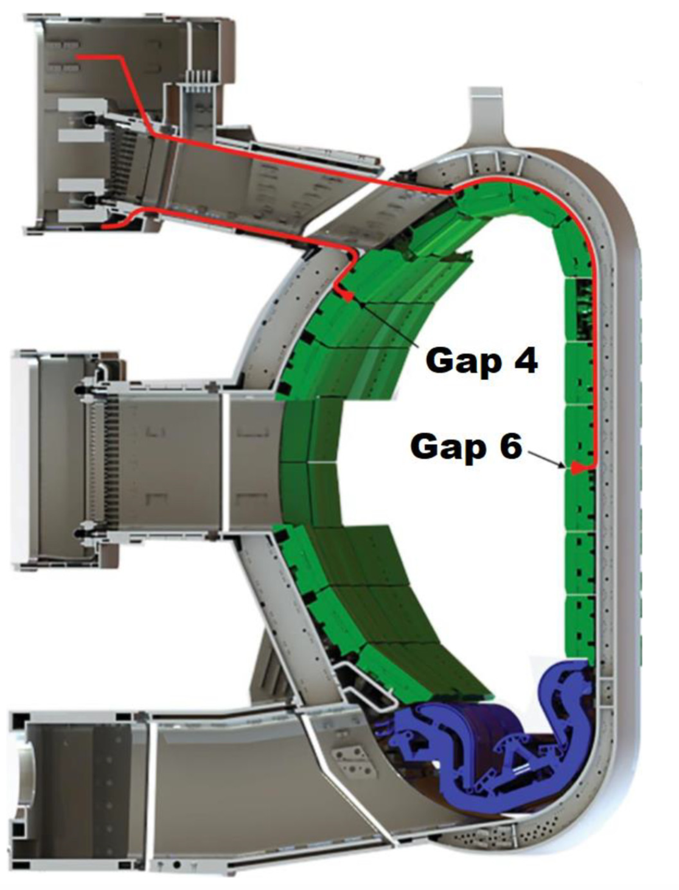
Figure 5. Location of the ITER PPR in-vessel components of gaps 4 and 6 in red.
The antennas and part of the transmission lines of gaps 4 and 6 were to be installed inside the vacuum vessel, as depicted in Figure 5. Due to direct exposure to the plasma, these antennas and the $90°$ bends connecting to the transmission lines were expected to suffer significant loads that could compromise their integrity.
The system of gap 4 had the antennas located in the low-field side (LFS) of sector 9, between the blanket modules (BMs) in rows #11 and #12. The support of the $90°$ bend was bolted to ITER standard in-vessel attachments welded to the wall [15]. From the 90° bends, the microwaves were routed the feed-outs at the bottom of upper port 1 using straight and curved sections of waveguide.
In the case of gap 6, the antennas installed were to be installed at the high-field side (HFS) of sector 7, between the BMs in rows #3 and #4. The support of the $90°$ bend would be attached to the vessel in the same way as in gap 4. The transmission line of gap 6 was then routed along the inner wall of the vacuum vessel between the bend and one of the feed-outs on the top of upper port 14. Further details about the design of the PPR system is provided in [16] and [17]. Figure 6 shows details of some components of these two PPR systems.
Figure 6. Details of some components of gaps 4 and 6 installed in-vessel.
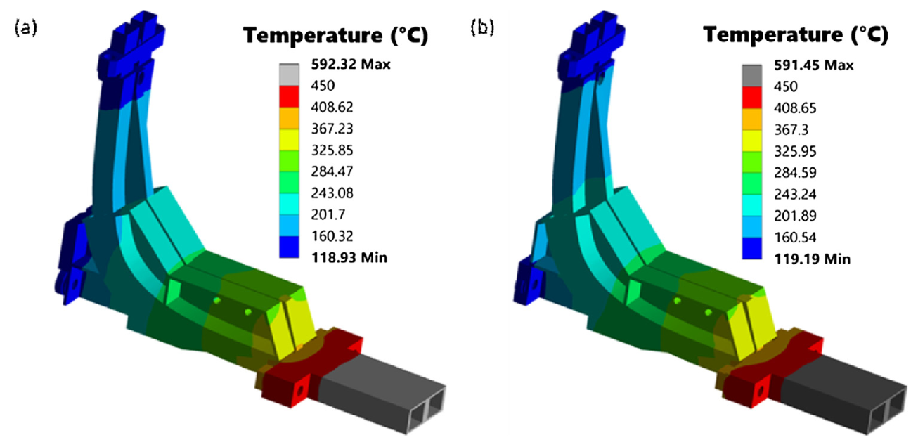
Figure 7. Temperature distributions of the front-end components of gap 6 after extending the design volume in the poloidal direction (a) and in the toroidal direction (b).

5.1. Thermal loads and material testing
As mentioned, the in-vessel components of gaps 4 and 6, namely the antennas and $90°$ bends, would be subjected to significant thermal loads that could compromise their integrity. Figure 7 shows the expected temperature distributions in these two components for gap 6, which were estimated using ANSYS Mechanical, by applying the load specifications for the PPR in-vessel components and following the ITER guidelines for thermal analyses. As shown, the maximum operation temperatures would be well above the limit of $450$ $°$C for the selected material (ITER grade stainless steel) under neutron irradiation. Thus, it was proposed that these components were manufactured from other materials, such as tungsten or a nickel-based superalloy [18].
To minimise the EM forces induced during plasma disruptions, the in-vessel waveguides were made from stainless steel, but copper-coated inside to keep ohmic losses at a minimum. Prototypes of these waveguides (see Figure 8) were tested at the IPFN-IST microwave laboratory. The obtained results (see Figure 9) show that the copper-coated stainless-steel waveguides have similar performance to the theoretical predictions and to copper-only waveguides both in O-mode and X-mode like polarisations. These results were reproducible for all the waveguide samples tested.
Figure 8. Stainless steel copper-coated waveguides.
Figure 9. Performance of the stainless-steel copper-coated waveguides (blue) against the copper-only waveguides (green) and theoretical predictions (red) both for O-mode and X-mode like polarisations.

5.2. Performance assessment of waveguides bends
As expected, the performance impact of the in-vessel oversized waveguide bends of gaps 4 and 6 was a critical aspect of the PPR design, namely the $90°$ bends just behind the antennas and the $125°$ bend of gap 4. It is well known that these bends are prone to excite higher-order modes and create resonances, which may adversely affect performance if not designed carefully. The $90°$ and $125°$ bends of the in-vessel PPR systems were first studied via 3D EM simulations using both ANSYS HFSS and CST Microwave Studio (MWS). Figure 10 (top picture) shows the results obtained with HFSS for the optimisation of the $125°$ bend, which was split into two identical 62.5° bends with hyperbolic secant geometry. The optimised shape (C9) clearly improved performance with respect to the constant radius bend across the $15-75$ GHz frequency range (with just a small degradation $<0.2$ dB is visible above $70$ GHz) while complying with the in-vessel space restrictions [19]. The results obtained for the optimised geometry were cross-checked and confirmed using MWS (bottom picture of Figure 10). Figure 11 shows the electric field distribution inside the optimised $125°$ bend, as obtained with HFSS for $15$ GHz, $45$ GHz, and $75$ GHz.
Figure 10. Performance of the constant-radius (baseline design) and hyperbolic secant $125°$ bends (top) and comparison between the results obtained with HFSS and MWS for the optimized design (C9) (bottom).
Figure 11. Electric field distribution inside the optimised 125° bend obtained with HFSS for: (a) 15 GHz , (b) 45 GHz, and (c) 75 GHz. Please note that the vertical scale in (c) is different from that in (a) and (b).
The $125°$ bend was prototyped to assess the EM performance of the optimised design and the manufacturing process, namely the copper-coating and the bending to the specified geometry. During the site acceptance inspection, some problems were readily identified in the received samples:
- All samples showed a lack of (copper) coating near the edge of the flanges, as shown in Figure 12(a), as well as in some spots near the flanges, as observed in Figure 12(b). The lack of copper was also visible inside the waveguides along the corners formed by the inner walls and in the walls themselves.
- Marks were visible in the inner surface of the bend, probably caused by some tool inserted in the bend during bending, as depicted in Figure 12(c) and Figure 12(d).
- A local shape deformation was clearly visible in all samples around the middle of the bend, as shown in Figure 12(e), where, per specification, there should be a straight section due to the connection between the two $62.5°$ hyperbolic-secant bends – as is visible in Figure 12(f), the deformation extends to the inner wall of the waveguide, which anticipates performance issues.
- Figure 12(e) clearly shows that the received samples are not symmetric components as specified and, judging by the relative position of its flanges, it seems the samples are all slightly twisted around the propagation axis.
- Finally, measurements taken as part of the site acceptance tests have shown that the internal section of the received samples is about $0.2$ mm (both in height and width) smaller than the specified dimensions.
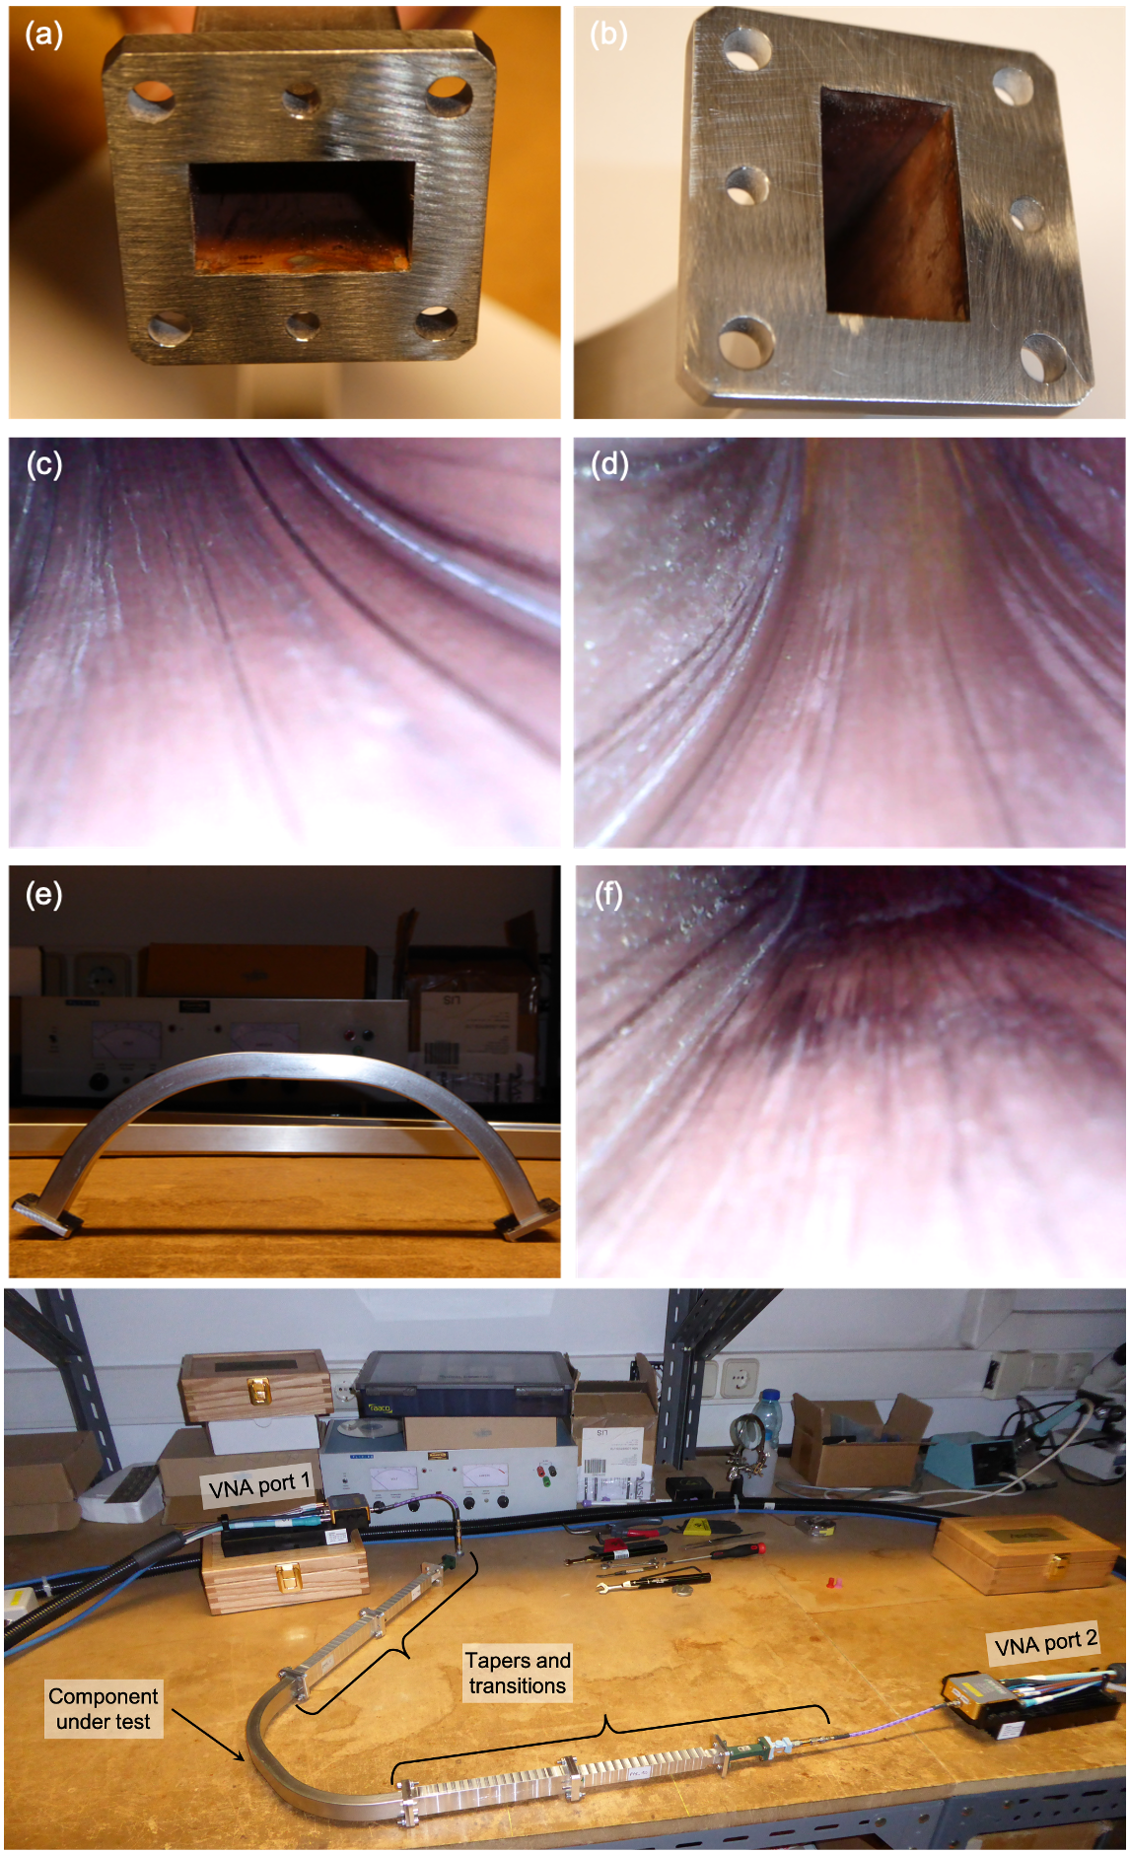
Figure 12. Prototype of the $125°$ bend (a) to (f) and experimental setup at IPFN-IST microwave laboratory (bottom) used to measure the EM performance of the prototype samples.
The main goal of the tests was to measure the performance of the samples in the frequency range $15-75$ GHz for the TE₀₁ waveguide mode (O-mode like polarisation), as used by the PPR system. The testing frequency range was covered using the standard frequency bands K (extended down to $15$ GHz), Ka, Q, and V. Waveguide tapers were used to enable the connection between the non-standard dimensions of the bend and the standard dimensions of the hardware equipment used in the tests. For each band, the measurements were preceded by a calibration for that particular band of the Vector Network Analyser (VNA) used in the tests. Due to the small attenuations of the bend in certain frequency ranges, the difference to the reference measurements was within the resolution limit of the VNA ($±0.1$ dB). Thus, the measurements presented here were performed by activating the Secondary Match Correction (SMC) feature of the VNA, which improves the resolution of the measurements by slowing down the frequency sweep.
For each tested sample, the measured attenuation was compared with α_{c} what can be expected from the analytical conductivity losses for the TE₀₁ mode propagating through a straight rectangular copper waveguide,
$$α_{c}\left[\text{dB/m}\right]=8.686\frac{2R_{m}}{bZ_{0}\sqrt{1-{k_{c}^{2}}/{k_{0}^{2}}}}\left[\left(1+\frac{b}{a}\right)\frac{k_{c}^{2} }{k_{0}^{2}}+\frac{b}{a}\left(\frac{1}{2}-\frac{k_{c}^{2} }{k_{0}^{2}}\right) \right]$$ | (3)
Here, $a$ and $b$, with $a>b$, are the waveguide cross-section dimensions, $k_{c}$ is the cut-off wave number, $k_{0}$ is the wave number corresponding to frequency $ω=2πf$, $Z_{0}$represents the free-space impedance, and $R_{m}={({ωμ_{0}}/{2σ_{Cu}})}^{1/2}$, where $μ_{0}$ is the free-space permittivity and $σ_{Cu}$ is the electric conductivity of copper.
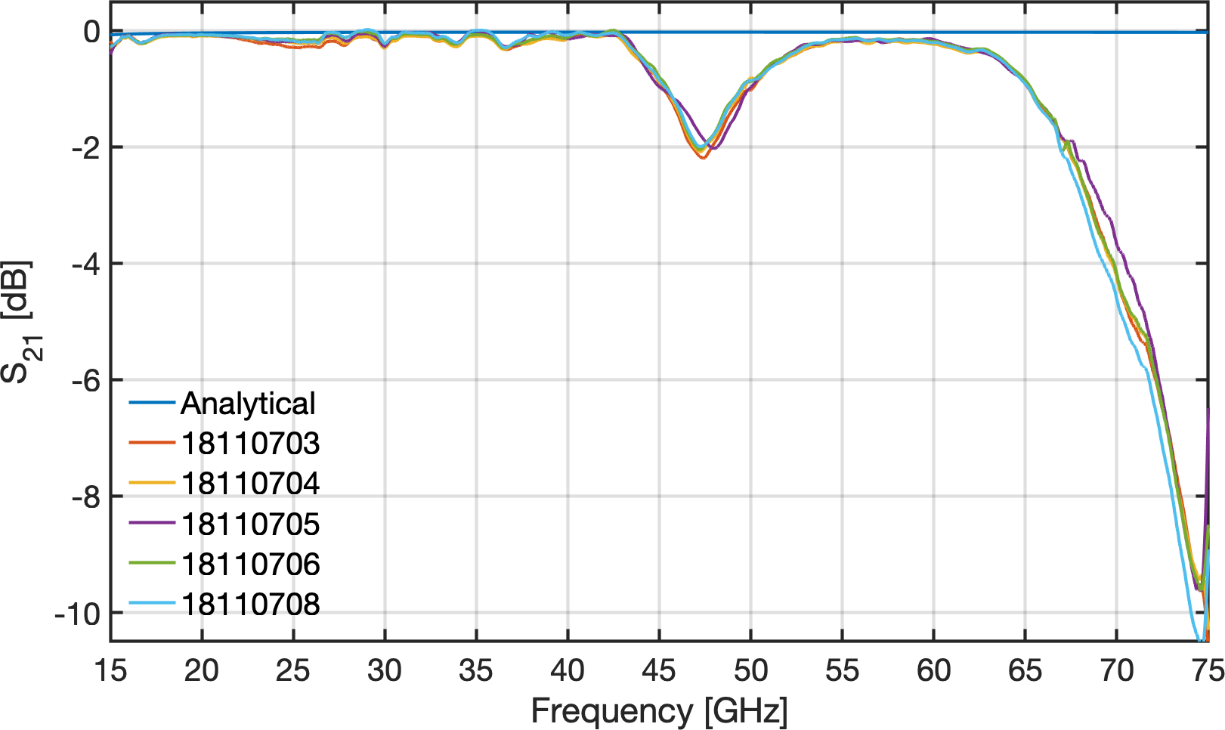
Figure 13. Analytical losses and experimental attenuation for the $125°$ hyperbolic secant rectangular ($20×12$ mm) stainless-steel copper-coated waveguide bends. The analytical losses were calculated using Equation 3 for a straight rectangular waveguide with the same dimensions and equivalent length of $0.33$ m.
The results obtained from the tests of the prototype samples are depicted in Figure 13, along with the analytical attenuation of a straight $0.33$m long rectangular waveguide with the same cross-section, as obtained from Equation 3. As can be observed for all bends, there are two frequency regions where the experimental attenuation deviates significantly from the analytical losses: between $43$ GHz and $54$ GHz, where the bends exhibit moderate attenuation (up to $2$ dB) and above $62$ GHz, where the attenuation rapidly increases from $∼0.5$ dB up to $\sim 10$ dB at $75$GHz. Out of these regions, all samples exhibit good performance, with the attenuation remaining below $0.5$ dB.
These results show that the bends are inadequate for the PPR system but were not a surprise given the observations made during the acceptance of the prototypes, which indicated that the (bending) process used to manufacture this component, although reproducible as demonstrated by the results of the tests, is clearly unable to provide the precision and accuracy required by the specified hyperbolic secant geometry, whose main goal is to mitigate the excitation of higher-order modes that are known to deteriorate performance. In fact, although not exactly coincident with the ones of the tested samples, the attenuations estimated with HFSS and MWS also exhibit two frequency regions where the performance of the bend deteriorates slightly with respect to the theoretical losses, which are shown to be mainly due to the excitation of the TE₀₂ mode. This similarity indicates that the bad performance of the prototype might be due to mode conversion losses into higher order modes, which are not mitigated as expected due to the local deformations and overall poor shape accuracy of the manufactured prototype. One of the lessons learned for future developments was that the prototyping required to validate the EM design should be separated from the prototyping required to validate manufacturing processes to allow for a better understanding of the root causes of performance issues.

5.3. Avoiding crosstalk in the in-vessel waveguide flanges
The ITER in-vessel waveguides consisted of multiple sections of parallel waveguides with multiple flanges. Therefore, crosstalk at the flanges was a concern. The envisaged solution consisted of matching male-female flanges with a centre pole to prevent crosstalk, as depicted in Figure 14. The results of testing a prototype flange (see Figure 15) have shown that the envisaged solution effectively reduces the flange crosstalk to negligible levels across the entire $15–75$ GHz frequency range.
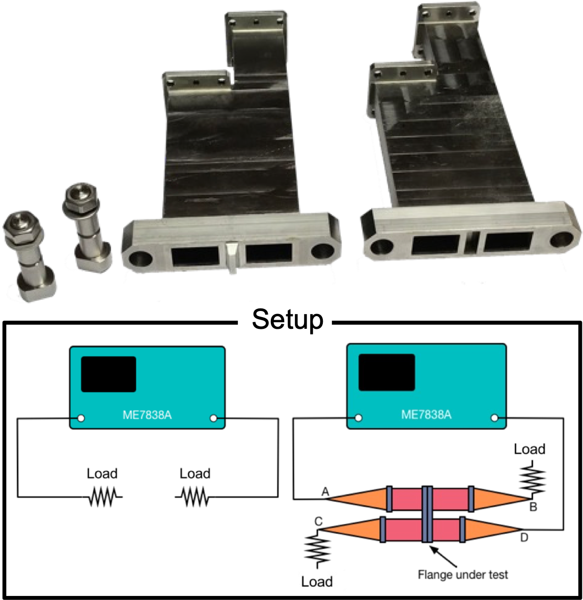
Figure 14. Prototype flanges designed to avoid crosstalk (top) and experimental setup to measure the crosstalk at the flanges (bottom).
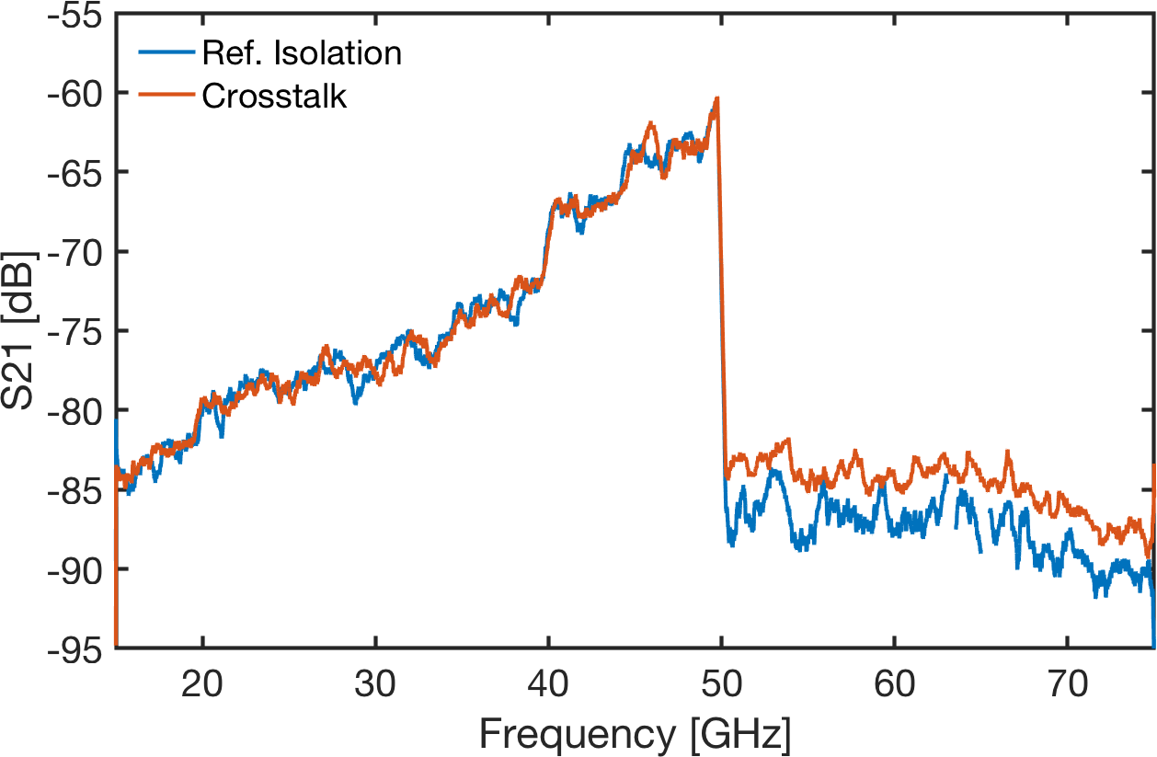
Figure 15. Crosstalk measurements on the prototype flange versus frequency.

5.4. Testing the integration of the antennas of gaps 4 and 6 between blanket modules
To optimise the design of the antennas for gaps 4 and 6, extensive simulations were performed using the REFMUL Finite-Difference Time-Domain (FTDT) code, which is capable of considering the geometric characteristics of the space between BMs where the antennas would be installed. From these simulations some concerns were raised regarding the effect of the blankets on the signals due to reflections and diffraction. Thus, prototypes of the antenna assembly, consisting of the antennas and feeding waveguides, were built and tested both isolated and integrated into a mock-up of the blanket modules to simulate the effect. An example of the prototype antennas and mock-up of the BMs for gap 6 are shown in Figure 16. The radiation patterns of the antenna assembly were measured in an $3.8×2.5×2$ m anechoic chamber with and without the BMs. Figure 17 shows the antenna inside the anechoic chamber during these measurements. Two different antennas were prototyped and tested:
- Antenna #1 (baseline): two parallel pyramidal horns with a length of $115$ mm, toroidal flare of $±2$ mm, and poloidal flare of $±1$ mm; and
- Antenna #2: two parallel pyramidal horns with a length of $115$ mm, toroidal flare of $±2$ mm, and poloidal flare of $±4$ mm.
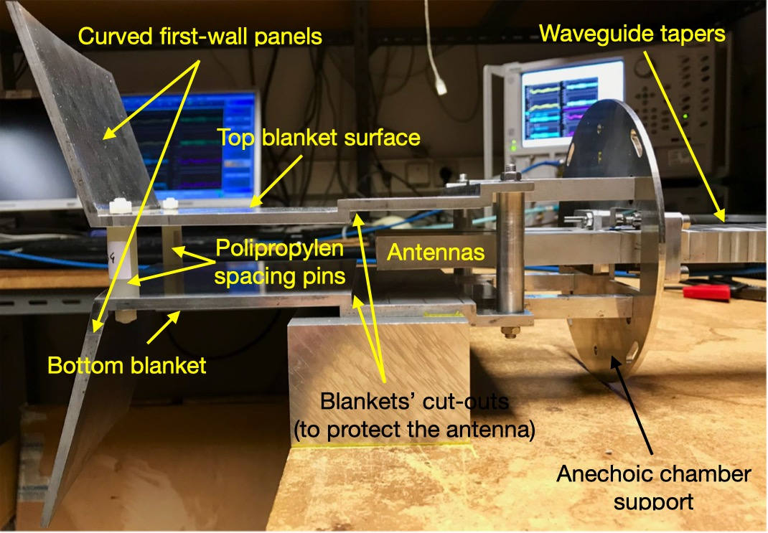
Figure 16. Prototype antennas and mock-up of the BMs for gap 6.
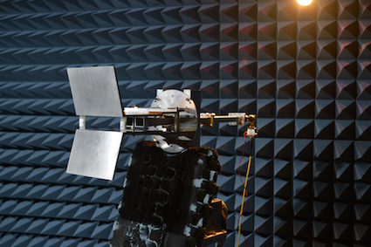
Figure 17. Prototype antenna assembly for gap 6 inside the anechoic chamber during the measurement of the radiation patterns.
To reduce the time required to complete the measurements, instead of full $360°$ scans the radiation patterns were only measured in the range $-120°$ to $+120°$ ($240°$ scans). For each frequency band, the radiation pattern of a standard calibrated horn antenna was measured to absolutely calibrate the radiation patterns of the Antenna Under Test (AUT). Before each scan, the phase centre of the AUT was aligned with the Probe Antenna (PA). In the measurements, both the AUT and the PA could be rotated in their vertical plane; the AUT was also able to be rotated in the horizontal plane. The measurement plane (E or H) was selected by rotating the AUT and PA antennas in the vertical plane as desired. For cross-polarisation measurements, the AUT and PA antennas were rotated such that they were in complementary planes.
For the different bands, the radiation patterns were measured at the following discrete frequencies:
- Ku band: $15$ GHz, $16.5$ GHz
- Ka band: $18$ GHz, $19.7$ GHz, $22.25$ GHz, and $24.8$ GHz.
- Ka band: $29.2$ GHz, $33.25$ GHz, and $37.3$ GHz.
- Q band: $42$ GHz, $45$ GHz, and $48$ GHz.
- V band: $55$ GHz, $62.5$ GHz, $70$ GHz, and $75$ GHz.
Depending on the frequency range, different setups were used in the anechoic chamber due to the need to keep the dynamic range of the measurements above $25$ dB for all bands (the loss of dynamic range occurs because the output power from the Agilent Technologies N8361A VNA used in the measurements decreases as the frequency increases with the simultaneous increase of the losses on the high frequency cables).
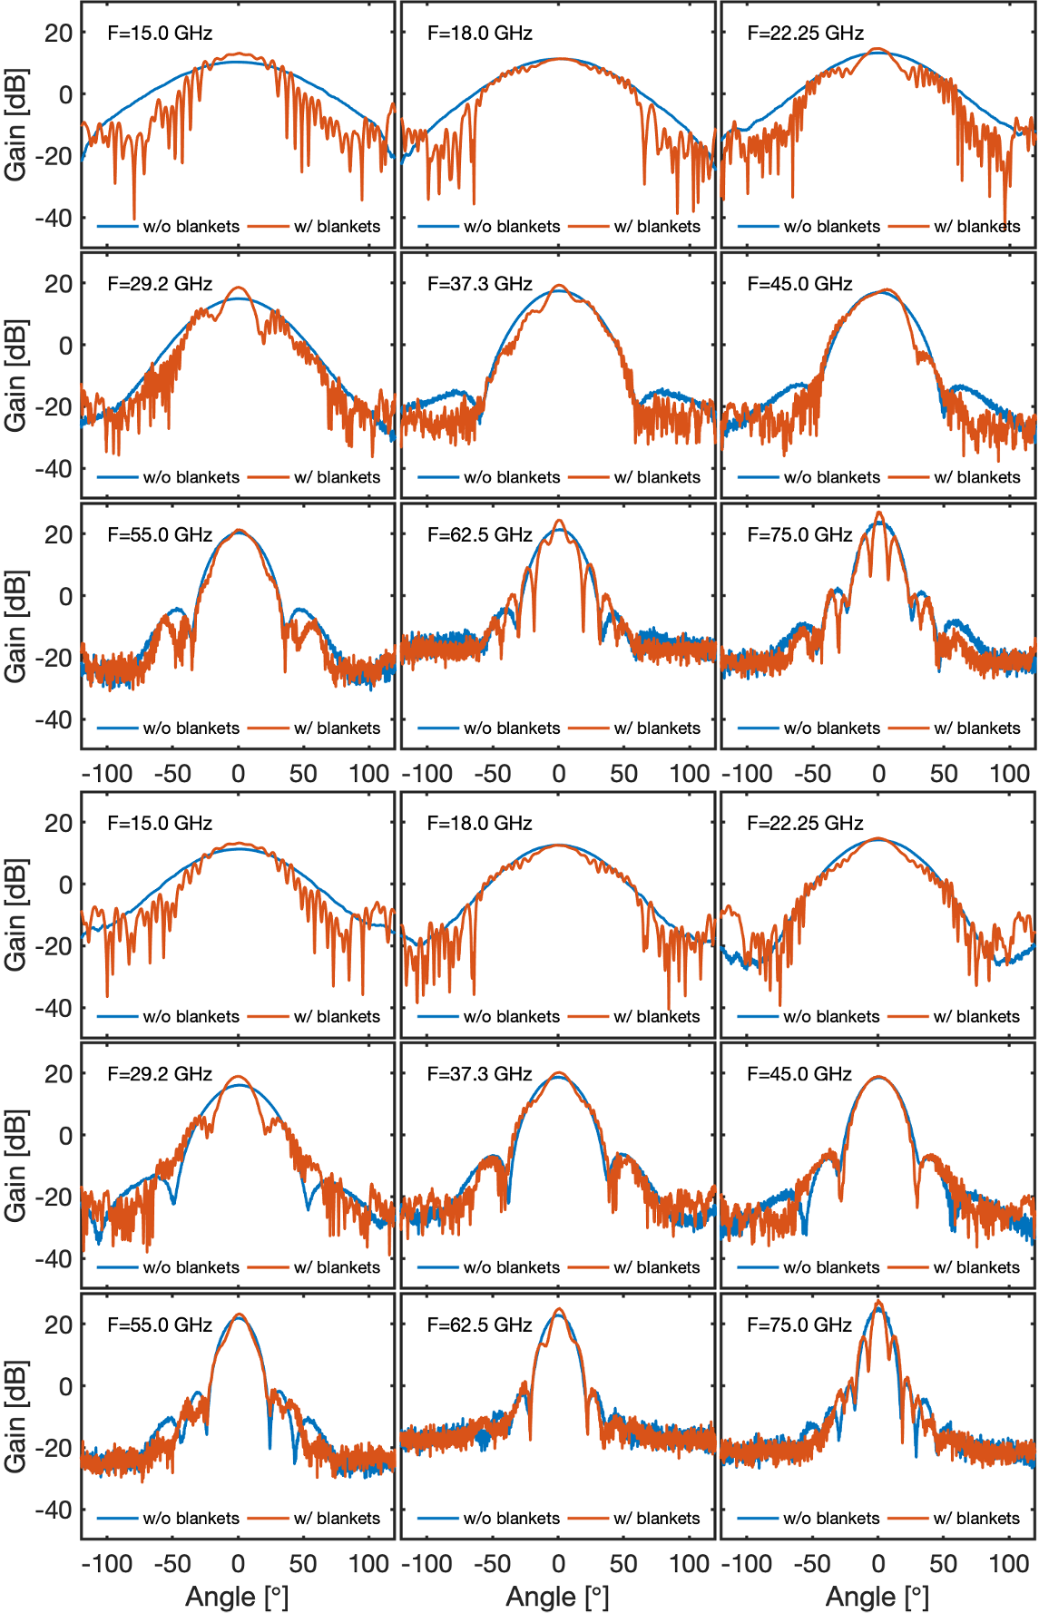
Figure 18. H-plane co-polar radiation patterns for antenna #1 (top) and antenna #2 (bottom), with (red) and without (blue) the BMs.
We expected the measurements to show the effects of the blanket modules to be most noticeable in the poloidal plane, which for the TE₀₁ mode corresponds to the antenna’s H-plane, due to the fact that, with respect to the dimensions of the antennas, the aperture between blankets is sufficiently large in the toroidal plane (antenna’s E-plane) so that it does not significantly affect the radiation patterns in this plane. The E-plane co-polar radiation patterns measured for antennas #1 and #2 with and without the blanket modules in place confirm these expectations showing that the modifications in the radiation patterns of both antennas are in fact not significant. For both antennas, the H-plane co-polar radiation patterns measured with and without the BMs are illustrated in Figure 18. As can be observed, the most noticeable effect of the blanket modules in the lower end of the frequency range is a narrowing of the radiated beam and the appearance of side- and back-lobes, while in the higher frequencies the effects are less important and, for some frequencies, barely noticeable.
The beam narrowing effect has to do with the larger directivity of the radiating structure formed by the blanket surfaces and first-wall panels, into which the emission antenna radiates. The side- and back-lobes have to do with the beam truncation effect induced by the BMs' cut-outs located near the antennas' apertures (see Figure 16), which create reflections that, because of the broader antenna beam, are more significant at the lower frequencies. For the higher frequencies, the dominant effect are the secondary lobes that appear near the main lobe. With respect to antenna #1, the modifications induced by the blankets in the radiation patterns of antenna #2 are less noticeable, again due to the larger directivity of this antenna, which makes it more insensitive to the surrounding structures.
The results obtained during the tests of the baseline design of the gap 6 antenna indicate that the BMs below and above the antennas shape the radiation patterns and, because of the cut-outs in the first-wall surfaces, originate reflections and resonance effects that have a negative effect on the measurement performance below approximately $35$ GHz. These effects can be partially mitigated if the baseline design is modified to increase its poloidal directivity, by increasing its poloidal flare. This design change significantly reduces the effects of the reflections in the first-wall cut-outs, which directly improved the system’s performance.
Another critical design parameter in terms of the system performance is the gap between the antennas and the cut-outs, in particular, at the lower end of the frequency range where the radiation patterns are very broad. The tests show that if this distance is reduced from the nominal $15$mm to $10$ mm the effect of the reflections in the first-wall cut-outs is reduced, improving the performance of the system.
If the above design changes are applied simultaneously, the effects of the structures surrounding the antenna are restricted to the K band ($15-26.5$ GHz) and the measurement performance of the system is significantly improved with respect to the baseline design. Furthermore, the tests show that these modifications can also help in mitigating the impact of the blanket modules if, after installation, the antenna is not exactly centred between the blanket surfaces, due to the tolerances of the different components involved.
In the case of gap 4, the in-vessel waveguides would run through the bottom of upper port 01, behind the BMs, close to the inner shell of the vacuum vessel, down to the antennas. The waveguides would be attached to the bottom of the upper port and to the vessel inner shell and could not be maintained or replaced during the lifetime of ITER. The antennas, which as for gap 6 consisted of a bi-static array of parallel small-flare pyramidal horns, would be installed at the low-field side (LFS), above the midplane, in the small space between two BMs consisting of two main components: (i) the shield block, a large stainless-steel block directly attached to the vacuum vessel, whose main purpose would be to reduce the neutron flux, and (ii) the first-wall, a relatively thin structure attached to the shield block and directly facing the plasma, whose main purpose would be to sustain the high thermal and nuclear loads generated during the plasma discharges. Near the antennas, the first-wall panels are slanted both in the poloidal and toroidal directions. The 3D EM simulations have shown that the BMs would modify the antenna radiation pattern, at the lower frequencies, and that the geometry and location of the cut-outs required to accommodate the antennas would have a significant negative impact on the EM performance. Moreover, 2D full-wave plasma simulations confirmed the modification of the antenna radiation patterns by the blanket modules and have shown, for gap 6, that the slanted geometry of the first-wall in front of the antennas could have a strong negative effect on the measurement performance of the system. In fact, the results of the simulations indicate that there would be situations in which the system of gap 6 could not be able to meet its measurement requirements. The 2D full-wave plasma simulations also indicated potential issues with the performance of gap 4 due to the specific geometry of the enclosure, in particular the fact that the first-wall surfaces above and below the antennas would be oblique to each other, forming an aperture which narrows toward the plasma. Therefore, as for gap 6, it was decided to build a mock-up of gap 4 and its environment to test the performance of this system. This mock-up has been procured and provided by the IO. Figure 19 depicts the mock-up and the PPR antennas during the tests.
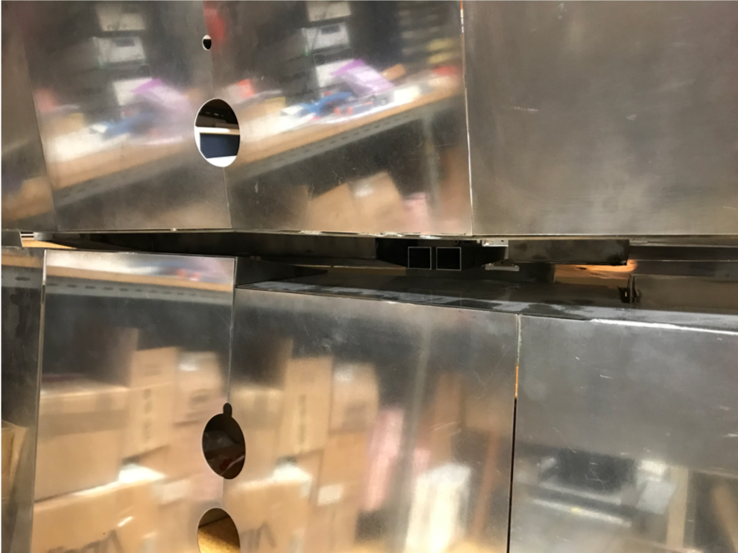
Figure 19. Mock-up of gap 4 provided by the IO featuring the relevant geometry of the first-wall surfaces and BMs surrounding the PPR antennas.
The tests were performed with the two antennas’ prototypes corresponding to the current baseline design and to the optimised design of the antennas developed for gap 6. The results obtained with the baseline design show that the measurement performance of gap 4 is very good, with the system being able to recover all the mirror distances with position errors below the target $±1$ cm margin, except in the K band, where the errors exceed that margin. For these lower frequencies, the very broad beam radiated by the baseline antennas, due to the small poloidal flare ($1$ mm) is deflected and reflected in the oblique first-wall surfaces, shattering the beam, and creating relevant side lobes, which produce multiple lines-of-sight that reduce the measurement performance.
With the optimised design, the results show that the measurement performance of gap 4 improves, mainly due to the higher poloidal directivity of the antennas, which reduces the level of deflections and reflections in the first-wall surfaces. Indeed, the results show that the performance of the system would be compliant with the target error margin across the entire operating frequency range of the PPR system ($15-75$ GHz), if it were not for the results obtained in the K band for the closest distance of the mirror ($25$ cm), where the position error exceeds that margin for some frequencies, if only by a few millimetres. Finally, the results also suggest that the performance of gap 4 might be further improved to achieve full compliance, by increasing the poloidal flare of the antennas, which in this gap, contrary to gap 6, would be possible due to the relatively large distance between the antennas and the surrounding components.
Concerning the measurement difficulties of gap 4, as indicated by the 2D full-wave plasma simulations, the tests with the baseline antennas confirm, although less severe, the estimated difficulties in the lowest frequency band, K, but do not show any problems in the highest frequency band, V. This discrepancy might be due to the 2D nature of the simulations, which, for the 3D geometry of the mock-up tests, collapse all energy in the poloidal plane and decreases the rate at which that energy dissipates, leading to an enhancement of the non-primary contributions to the measured signal [20].

5.5. Lessons learned in ITER PPR
Although the ITER PPR system was descoped in 2020, the work performed to comply with the many interfaces and restrictions posed by its integration in ITER has revealed crucial to the development of many of the design methodologies that are currently being used in the design of a PPR system for DTT and in the conceptual design of the PPR for DEMO, which face similar challenges as the design for ITER. The extensive use of both EM and thermo-mechanical simulations to expedite the prototyping phase was also a key takeaway from the development of the ITER PPR system.

6. Microwave Reflectometry as a Plasma Position Diagnostic for DEMO
The objective of MW reflectometry in DEMO is to determine the radial edge density profile and to provide data for real-time control of plasma position and shape [21][22][23]. In order to fulfil its requirements, reflectometry shall be able to measure the plasma electron density profile in the pedestal region, where the high-density gradient occurs, with a temporal resolution of $1$ms, maximum precision of $5\%$, maximum noise level of $2\%$, and maximum latency of $0.01$ s [24]. To be able to provide shape information, the system will use several antennas distributed at several poloidal locations, with direct access to the plasma [25]. Depending on the location, each reflectometer will access the plasma along a specific line-of-sight. Therefore, ray-tracing and 2D Finite-Difference-Time-Domain (FDTD) simulations were conducted to assess the expected performance of the reflectometers at the various locations. The results showed that close to the equatorial plane a single pair of antennas can provide good spatial resolution. In regions of higher plasma curvature, however, clusters of 3-5 antennas (1 for emission and 2-4 for reception) may be needed to fully capture the reflected waves [26]. Considering measurements in 16 gaps on a poloidal plane around the plasma, up to 80 antennas might be required to fulfil the measurement requirements. Figure 20 shows possible poloidal locations for these antennas ($100$ antennas were simulated) and the simulation results for three of those locations, illustrating the need for clusters of antennas at the more extreme positions. The dimensions of the antennas and feeding waveguides are driven by the lowest frequency ($15$ GHz) used by the system, which corresponds to a density of $n_{e}=0.3×{10}^{19}$ m^{–3}.
Figure 20. Poloidal distribution of the antennas aligned perpendicularly to the separatrix tangent line (left) and their expected performance at three locations (right) for DEMO when the LOS is set perpendicular to the wall. The smaller blue boxes correspond to the region to place the antenna setup and the larger blue rectangles correspond to some examples of the selected region of interest for the tested poloidal positions [26].
The integration of such a high number of antennas and waveguides with the breeding blanket (BB) is by itself an extremely challenging task. In addition, these components need to endure radiation loads far exceeding those expected for ITER during long operation periods, and their design must be compatible with the DEMO Remote Maintenance (RM) systems, such that they can be replaced in case of failure. The Diagnostics Slim Cassette (DSC) concept, explained in detail in section 6.1, aims to address this requirement, while providing a feasible solution for the integration of all the antennas and waveguides with the BB [23][27].
The plasma-facing antennas are foreseen to be made of tungsten, the material used in the BB first wall. To keep erosion below $10$ $μ$m per year, it has been recommended that the antennas are retracted from the BB surface by about $100$ mm — erosion leads to higher surface roughness, which increases the reflection coefficient and the voltage standing wave ratio (VSWR), and therefore the losses. The waveguides are proposed to be made of EUROFER with copper coating for increased conductivity, and must connect the antennas to the ex-vessel, crossing the primary vacuum boundary.
As with the ITER PPR system, the integration of MW reflectometry in DEMO is a multidisciplinary endeavour. EM simulations are required to optimise the location and design of the antennas, and CAD design and integration studies, such as space occupation, RH compatibility, and definition of interfaces with other systems, are essential. Additionally, the integration of the antennas and feeding waveguides inside the vacuum vessel will have an impact on the waveguide routing and may impose bends that if not carefully designed may affect the SNR. Neutronics simulations (using MCNP) [28,29] and thermo-structural [30,31] analyses play an important role not only to ensure the reliability of the diagnostic but also to provide information about any deformations that may be induced on the components under the prescribed loads and the impact on the diagnostic measurements permitting to establish a correction to apply to minimise deformation effects if the thermal load is known.
Like the ITER PPR system, the additional components to implement MW reflectometry in DEMO may not be classified as requiring scheduled remote maintenance but must be prepared to an opportunistic operation of maintenance. An integrated and holistic approach is used to design the DSC considering the other systems, the expected remote maintenance operations, such as cutting/welding, alignment, grasping, manoeuvring and transportation, the Technology Readiness Levels (TRL) of the available tools and their availability during the lifetime of the reactor. In [27] the DSC was updated to be compatible with the hybrid kinematic mechanism designed to transport the BB [32].
The maintenance addresses nominal operations, i.e., operations that are planned and expected to be performed. A failure is considered when a nominal operation is interrupted. A risk of failure may always occur no matter how well designed and integrated the reflectometry system is in DEMO. Failure mode, effects, and criticality analyses (FMECA) are used to detect, analyse and find solutions to avoid the failures, or to mitigate their effects on the performance of the system. An initial FMECA of the DSC RH operations was performed, and mitigation actions were proposed [27]. In case of failure, the operation shall be interrupted, and the following actions may be needed: i) start a recovery operation, where no additional equipment is required, or ii) start a rescue operation, involving the support of additional remote maintenance systems. The recovery and rescue operations are planned to consider all possible failure situations.

6.1. The DSC concept
The proposal to integrate MW reflectometry in DEMO is the Diagnostics Slim Cassette (DSC), a slim, solid EUROFER structure with 20-25 cm of toroidal thickness to be attached to or integrated with the blankets [23]. The DSC will host the antennas and their feeding waveguides, which are routed to the upper ports, as detailed in Figure 21. The plasma-facing antennas are grouped around $16$ locations, known as gaps G1 – G16. The gaps are planned to be arranged in three toroidal planes, to avoid clashing between the waveguides (each with an inner cross-section of $19$ mm $×$ $9.5$ mm).
The number of antennas in each location was derived from ray-tracing simulations [26]. However, their arrangement is also dependent on space restrictions in the upper ports, where waveguide extensions will be used to connect the DSC to the primary vacuum boundary. Due to the space restrictions, the waveguides must be grouped in sockets and routed side-by-side with the blanket pipes [27]. The antenna arrangement is then influenced by two main constraints: the need to avoid clashing between waveguides belonging to different gaps, and the requirement of grouping the waveguides in a small number of sockets.
To assess the possibility of symmetrical waveguide distribution, a CAD model was developed for the antenna clusters in the first-wall of the DSC, aligned perpendicular to the separatrix. The options are illustrated in Figure 22 and consist of: (a) two antennas aligned vertically; (b) $2$ antennas aligned horizontally; (c) a cluster of $3$ antennas aligned horizontally; (d) a T-shape alignment of 4 antennas, with the emitting antenna placed below the receiving antennas (suitable for the divertor region); and (e) $5$ antennas, in ‘$+$’ and ‘$×$’ shapes, respectively. These two shapes, being complementary, can be used together to maximize the number of waveguides that can be routed without clashes.
The arrangement presented in Figure 22 was optimised to maximise the number of reception antennas, while minimising the number of sockets needed to route the waveguides in the upper port. It must be noticed, however, that the waveguide bends were not yet optimised from the point of view of EM performance.
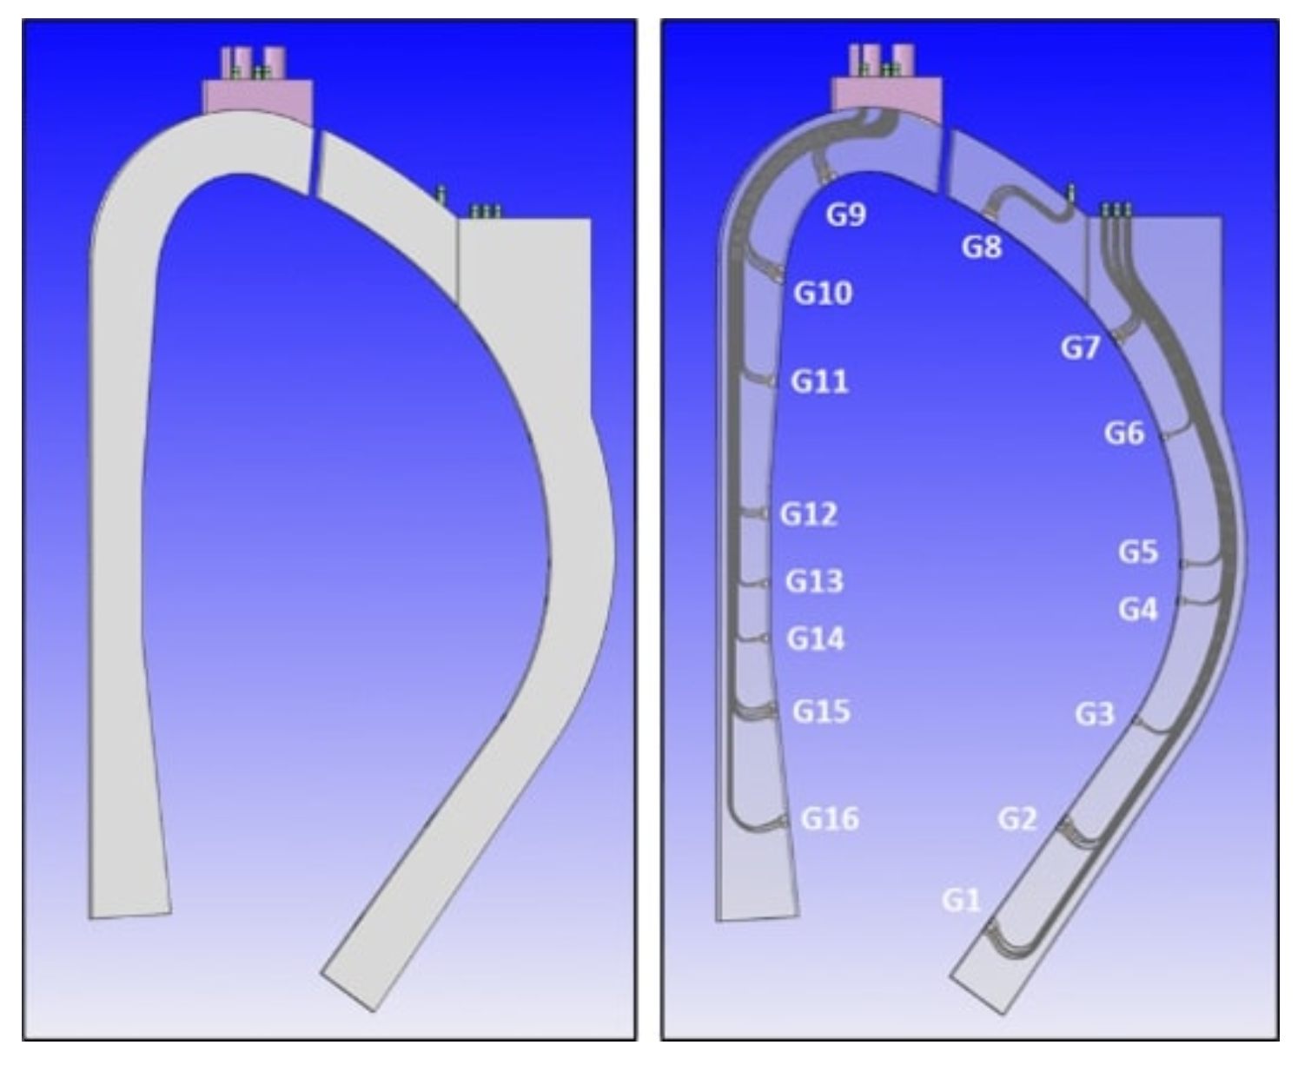
Figure 21. Poloidal view of the DSC with (left) and without (right) applying transparency showing the waveguide routing.
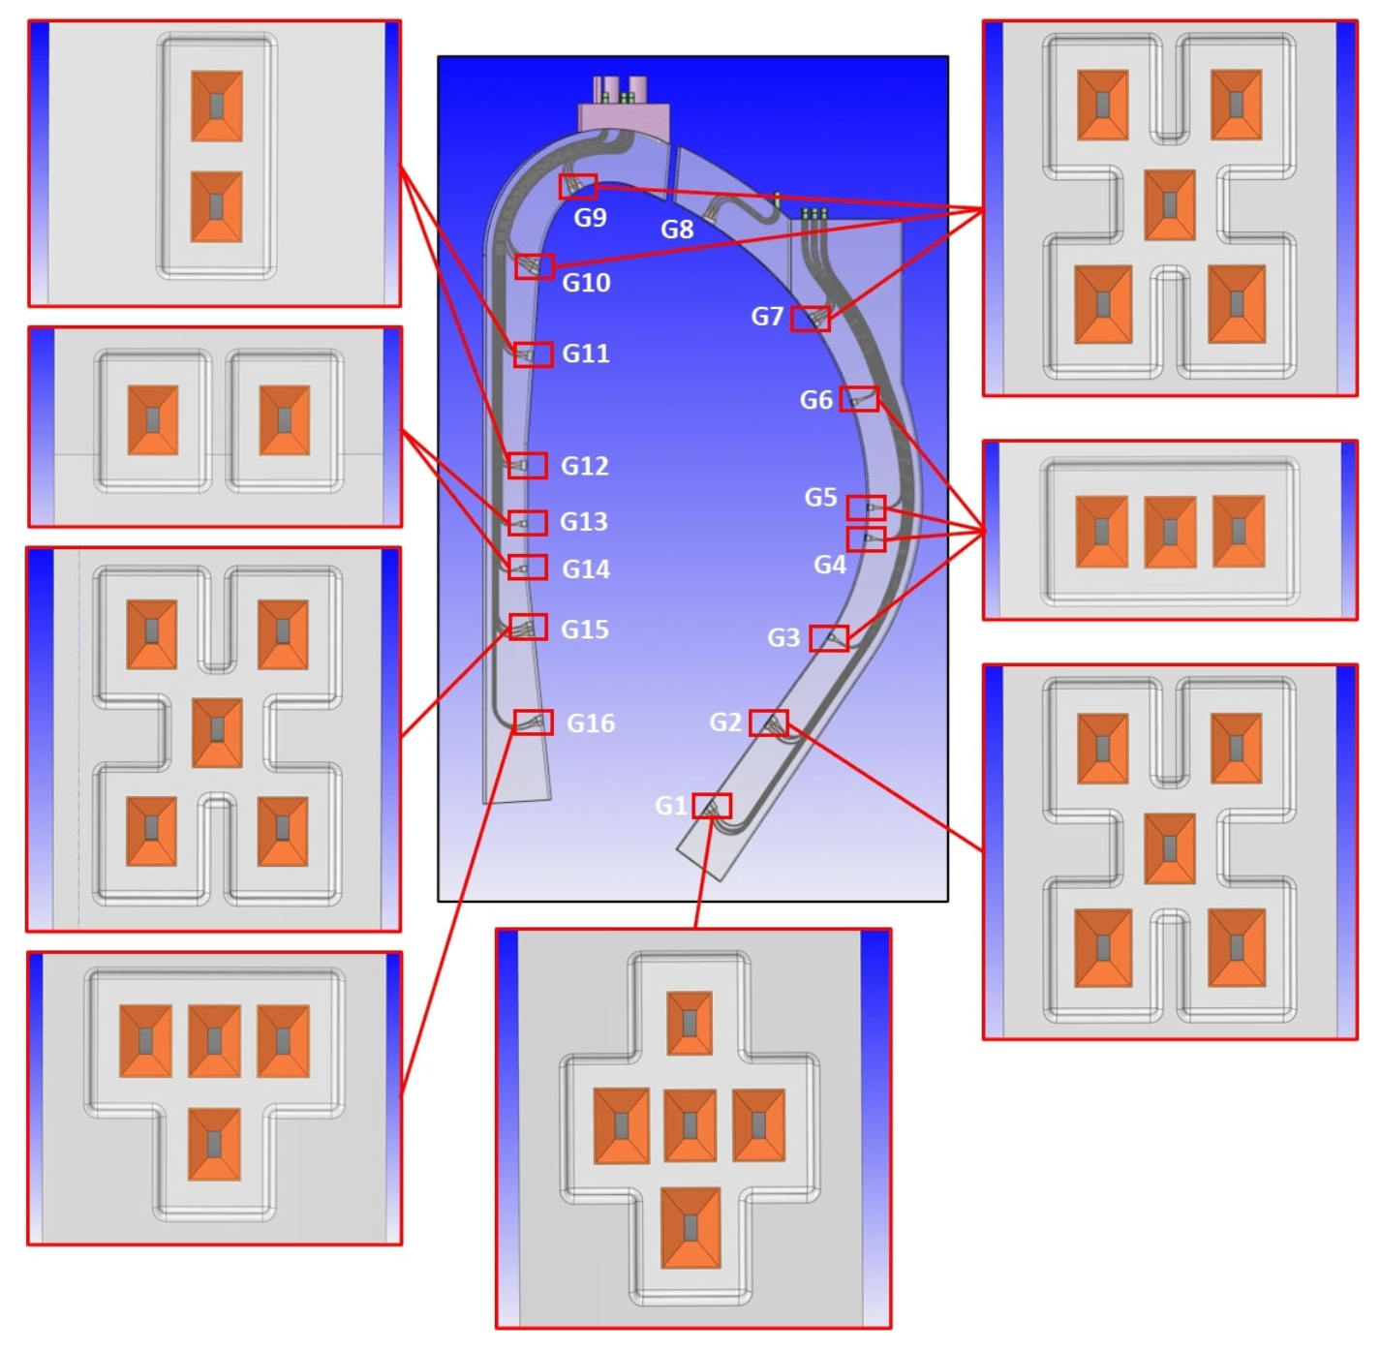
Figure 22. Possible distribution of antennas in the first-wall DSC openings [29].
One important question to address in an extreme environment like DEMO is whether the shapes of the waveguides in the DSC are preserved, to minimize power losses. Thermal analyses can be used to assess the waveguide deformation and its impact on the propagation of the EM waves. The full analysis performed for the DSC outboard segment is presented in [29,33]. The expected deformation of the waveguides in the DSC is illustrated in Figure 23, with the maximum values obtained in the antennas and waveguides located closer to the equatorial plane.
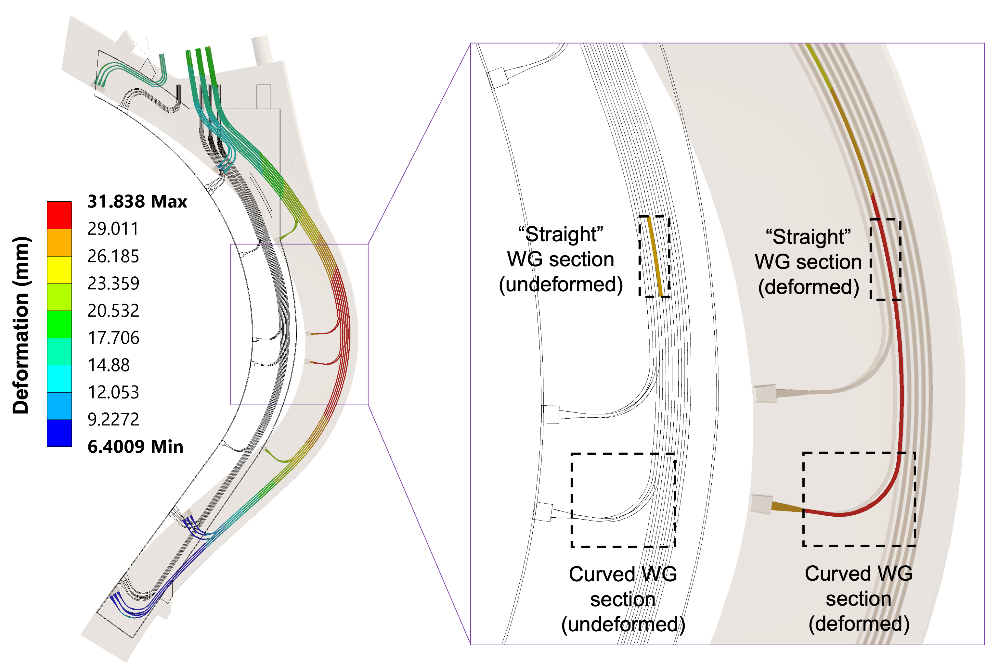
Figure 23. Preliminary results for the expected deformation of the waveguides inside the DSC (exaggerated representation). The waveguide sections selected for the preliminary EM performance assessment are highlighted on the inset.
Once the expected deformations of the waveguides are known, the performance of the reflectometry system can be assessed by conducting EM analyses that include the entire transmission lines from the source up to the antennas. However, considering that the length of the in-vessel transmission lines alone is approximately $21$ m (including the waveguide extensions), and the span of frequency bands, simulating the complete transmission lines would require very extensive computational resources. Therefore, critical segments of the transmission lines containing the larger expected deformations were selected for a preliminary assessment using ANSYS HFSS. The input for the simulations was the deformed geometries presented in Figure 23, divided into smaller components and then chosen for the simulations according to the deformation values. Two important waveguide sections were thus selected: a curved section, just before one of the antennas, and a straight section between the antennas and the upper ports (both highlighted on Figure 23).
The EM analyses aimed to estimate the power losses and compared them between the undeformed and deformed waveguides, not only for the fundamental mode, TE₁₀, but also for other relevant higher-order modes. Symmetry boundary conditions were applied to the waveguides to increase the simulation speed. The frequency was swept between $15$ GHz and $75$ GHz, with meshes optimized for to each band (Ku, K, Ka, U, and V) to further optimize the simulation times. Nevertheless, all these simplifications were not sufficient within the available computational resources to complete the analysis for frequencies above $75$ GHz.
Figure 24. Attenuation of the TE₁₀ mode for the two selected waveguide sections.
Comparing the losses obtained for the two selected waveguide sections, presented in Figure 24, one can observe that the straight section exhibits, at most, a very small power loss of less than $0.12$ dB, at 35 GHz. This has a minor impact on the overall system performance. On the other hand, the curved waveguide section has much higher losses, mostly for frequencies close to 50 GHz. In this case, losses above 1 dB may compromise the measurements, since they will be propagated by the number of curves in each transmission line. These losses were expected, as the shape of the waveguide bends, which is critical to avoid losses due to mode conversion [34,35], is not yet optimized at this stage. Previous simulations for the $90°$ bends of the ITER PPR system have shown that curves with optimized hyperbolic secant shapes can eliminate losses of this magnitude [35]. These optimisations will be implemented at a later design stage, when the number of antennas and waveguides and their positions within the system are fully determined.
Compared to the losses due to lack of optimisation of the waveguide bends, waveguide deformation due to thermal loads has a small impact on the microwave propagation (in fact, slightly lower losses were obtained with the deformed geometries). Nevertheless, it can be concluded from this study that for optimal performance the optimisation studies must consider the operation conditions.
Multiple aspects must be considered in the design of diagnostics for DEMO and those were taken into consideration in the design of the DSC. Space restrictions must be considered in the BBs and in the equatorial and upper ports regions. The harsh conditions of operation (radiation & heat loads) impose restrictions on the design and in the selection of materials, such as in the BB region, where only metallic components are allowed, and cooling systems are needed. Also, plasma-facing components need to be retracted in protected locations. Finally, RH compatibility must be considered early in the design of components that will be installed in areas where hands-on maintenance will not be possible.

6.2 Main achievements and future work on the development of MW reflectometry for DEMO
Fusion reactors are highly complex devices. The harsh environment and high number of interfaces between their multiple systems impose many challenges to diagnostic integration and calls for an iterative design process. The MW reflectometry system for DEMO is at the conceptual design phase and a considerable amount of work has already been done concerning its integration inside the vacuum vessel. The use of high-performance codes such as REFMUL enabled the development of synthetic reflectometry diagnostics that have been used to optimise the location and distribution of diagnostic antennas. The design of the system strongly benefited from the work performed for the ITER PPR system, which has provided design solutions that have been tested in relevant prototyping activities. However, much more work is still required to address the many issues that persist:
- the interface between the DSC and the BB, including the respective cooling services.
- the detailed definition of the antenna configurations in the first-wall and the waveguide routing inside the DSC.
- the interface for attaching/detaching the waveguide extensions to/from the BB chimneys.
- the limited space available in the upper port (especially at the inboard) and the need to avoid toroidal bending of the waveguides.
- the displacements between the vacuum vessel and the blankets, which must be accommodated by the waveguide extensions, and the design of the in-vessel/ex-vessel waveguide transitions.
The listed issues are not only dependent on the design of the reflectometry system itself, but also on the outcomes of the R&D being performed for other DEMO systems, such as the BBs and the RH system. Addressing these issues requires extensive simulation work, which involves CAD design and modelling, nuclear, thermo-mechanical, seismic, EM analyses, and EM simulations. A comprehensive structural analysis will also be required to demonstrate considering the applicable codes and standards that the system is capable of sustaining the prescribed loads and loading conditions, thus qualified for its intended use.

7. Plasma Position and Shape Reflectometry in DTT — a Test Bed for DEMO
The Divertor Test Tokamak (DTT) facility is a good test-bed to test and validate relevant non-magnetic control diagnostics contributing to improve their design and implementation in DEMO. For this reason, plasma position and shape reflectometry (PP&SR) is being investigated for installation on DTT with the aim of testing its capabilities in view of its application in DEMO as a complementary/backup system for the magnetic sensors. In DTT, the PP&SR system should use four lines-of-sight: one in the LFS midplane, one in the upper vertical port and two in the HFS region. Depending on the physical space available, a full band configuration (K, Ka, U, V, W and D band) or only a subset of it will be used by the reflectometers at each line-of-sight to monitor the full radial density profile or the regions around the last closed flux surface. The utilization of FDTD codes enables a detailed description of the reflectometers, which includes aspects such as propagation in realistic plasmas, specific location within the vacuum vessel, and access to the plasma. Additionally, the results of these simulations can be used to test new signal processing techniques. To predict the behaviour and capabilities of the proposed reflectometry system for DTT, three synthetic diagnostics (SD) were prepared. These SDs correspond to three O-mode reflectometers located on the LFS, with one on the midplane and two others located away from the midplane [36]. The simulations were performed using the 2D FDTD full-wave code REFMULF in two plasma scenarios envisioned for DTT, namely the 5 MA single null (SN) and double null (DN) configurations during the start-of-flat (SOF) phase of the discharge. Since 3D simulations are computationally intensive and require access to high-performance computer (HPC) facilities, the use of 2D codes is more common. However, it is important to evaluate if a 2D model is sufficient to describe the problem at hand and what compromises may be involved in using such a model, or if a 3D approach is necessary, especially since the received power can be a concern on larger devices. To address this, simulations were carried out using two full-wave codes, namely REFMULF (2D) and REFMUL3 (3D), to make a comparison between the two [37].
Figure 25. Cross-section of the DTT vacuum vessel showing the LFS $45°$ synthetic reflectometer.
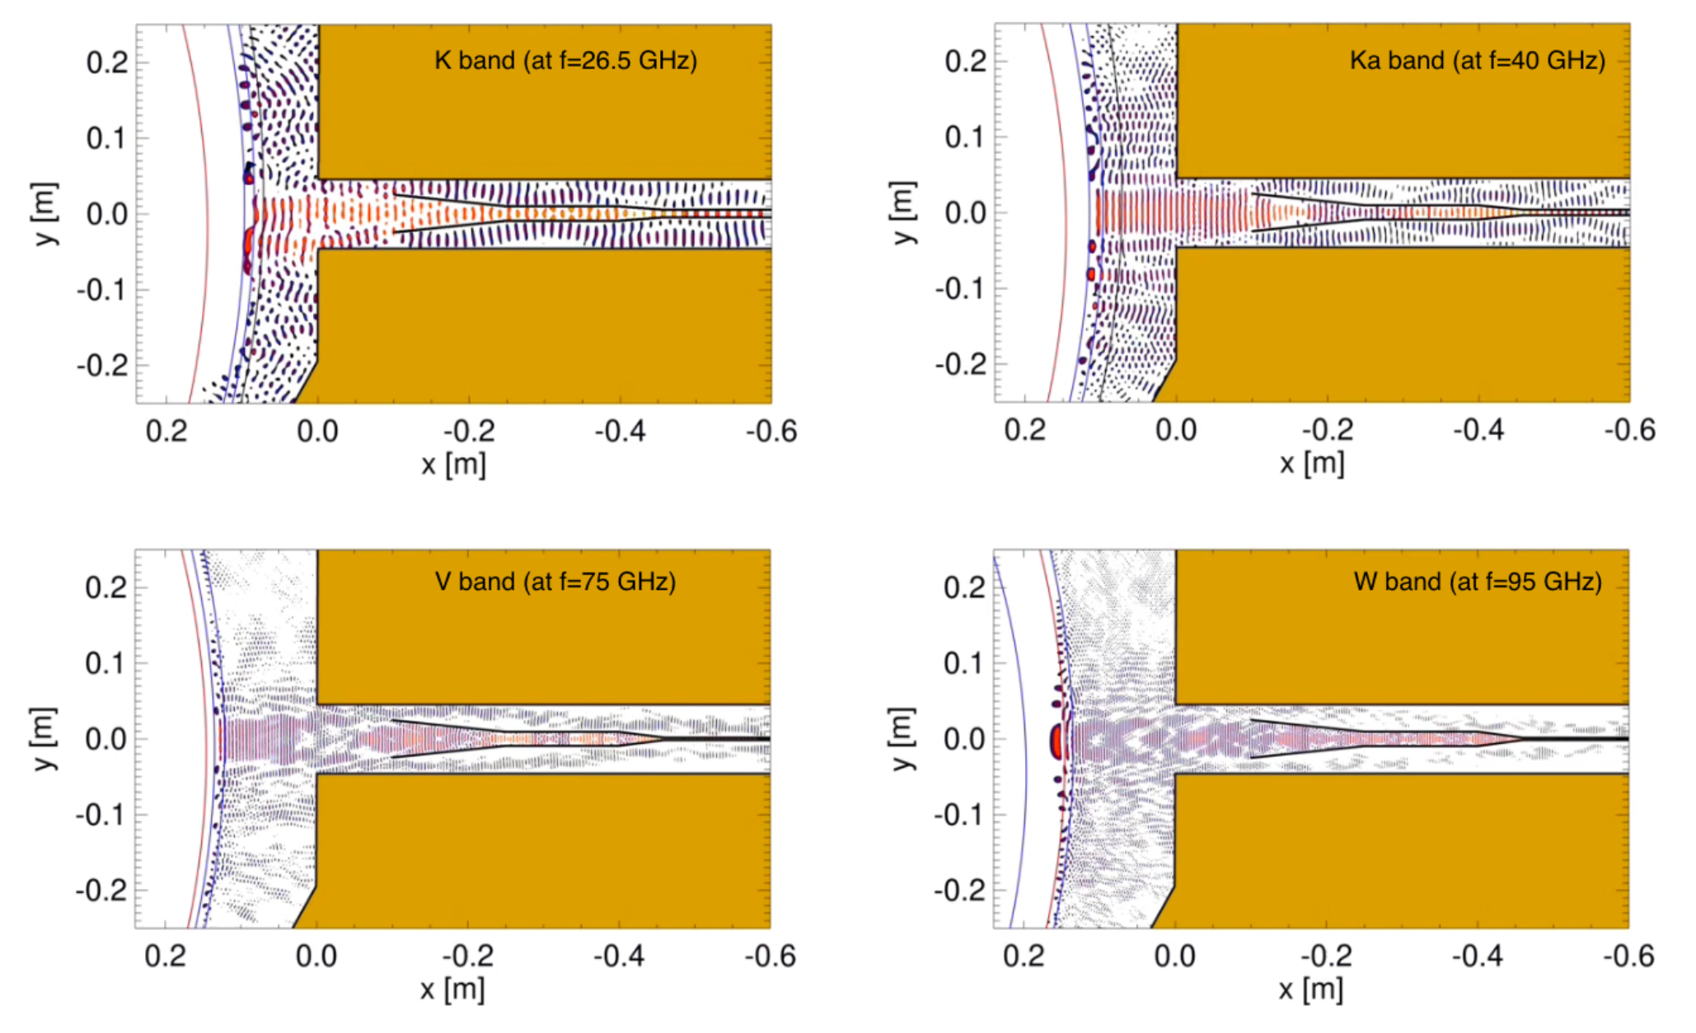
Figure 26. Snapshot of gap $45°$ in the DTT SN plasma scenario during a sweep of the K band at $f=26.5$ GHz (top left), Ka band at $f=40$ GHz (top right), V band at $f=75$ GHz (bottom left) and W band at $f=95$ GHz (bottom right).
Figure 25 represents a cross-section of the DTT vacuum vessel showing the LFS $45°$ synthetic reflectometer. Figure 26 depicts snapshots of the full system 2D simulations for gap $45°$ during a SN plasma at four frequencies corresponding to the K ($f=26.5$ GHz), Ka ($f=40$ GHz), V ($f=75$ GHz), and W ($f=95$ GHz) bands. Although it is not shown here, the Q band was also simulated. Based on the simulations, the LFS reflectometers at gaps 0°, 45°, and -60° demonstrate good performance with measurement errors within the required ±1 cm and small deviations, of the order of some millimetres, at the separatrix. These simulations consider the plasma and surrounding structures, as well as their interplay, demonstrating that the proposed reflectometer positions (or any small variations) are suitable for DTT. These results are encouraging for the implementation of reflectometry systems at DTT and represent an important milestone for reflectometry in D-shaped tokamaks. Even a reduced system with gap 0° and only one of the other two gaps (45° or -60°) would be a significant advancement for reflectometry in general, and for DTT and DEMO, as reflectometry has never been used before to measure the density profile from a location away from the midplane in a D-shaped tokamak.

8. Development of a Compact Reflectometer
The number of channels needed to achieve good poloidal and toroidal plasma coverage in fusion reactors like DEMO is larger than in current machines, which could take advantage from the use of compact and modular millimetre wave back-ends.
The large scale availability of high performance Monolithic Microwave Integrated Circuits (MMIC) at affordable prices, lead IPFN-IST to develop and prototype a coherent fast frequency sweeping RF back-end using commercial MMICs.
The new back-end system was designed to be able to accommodate different frequency ranges in a flexible way. Thus, the core back-end covers the NATO J-band (10 GHz to $20$ GHz) and is capable of driving external full-band frequency multipliers to achieve ultra-wideband coverage up to $160$ GHz. Although developed for fusion plasma diagnostics, this new compact reflectometer may also be used in other FMCW radar applications, such as space re-entry experiments. The details of its implementation are described in [39].
The system architecture is shown in Figure 27. Heterodyne radars use a microwave sweep oscillator to generate a signal, which is then used for different purposes in the circuitry: (i) for target probing, through the transmission channel (Ax); (ii) to drive a frequency translator. The frequency translated signal is used to drive two mixers: the front-end mixer of the receiver channel (Bx), which collects the reflecting signal from the target and generates the beat signal around the Intermediate Frequency (IF) carrier, and the local reference mixer that generates the reference signal used on the quadrature detector to demodulate the reflected signal. The fact that the IF is generated by frequency translation of the probing signal ensures the coherence of the system [40]. This approach improves the radar dynamic range with respect to a homodyne detection. The developed system uses two high-frequency PCB boards: (i) the back-end board, which is responsible for generating all the signals (shaded green in Figure 27) and the quadrature detector board, which is used to demodulate the reflected signal, providing amplitude and phase information (shaded pink in Figure 27). The front-end part of the system (yellow-shaded area in Figure 27) includes the final frequency multipliers, mixers, transmission lines and antennas.
Figure 28 shows a prototype of the compact reflectometer being tested. To be capable of efficiently driving external frequency multipliers, the system generates full band signals exceeding $8$ dBm. To keep all undesirable harmonics are at least $15$ dB below the desired output across the entire frequency range of interest, all signal paths were fine-tuned using appropriate in-line attenuators. The system also proved capable of coping with low-level reflected signals.
The back-end and in-phase & quadrature (I/Q) boards include EM shielding and were designed for easy installation on a standard 3U $19$′′ rack.

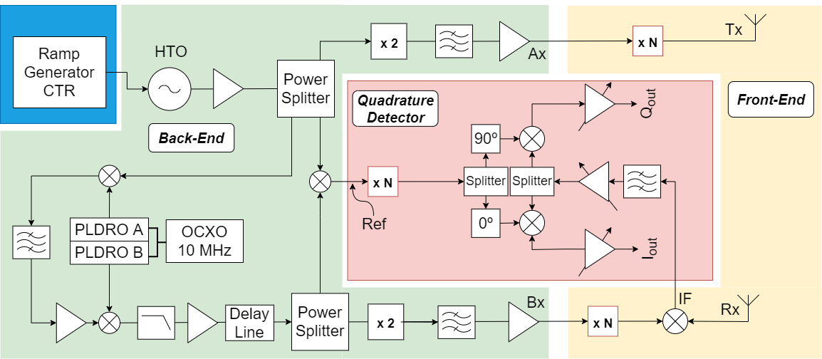
Figure 27. Block diagram of the compact reflectometer.
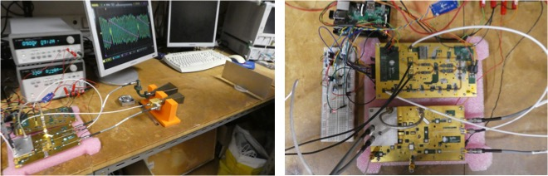
Figure 28. Compact reflectometer prototype being tested with a metallic mirror, set-up (left) and top view on the electronic hardware (right).
The precision of FMCW radars is known to be strongly dependent on the linearity of the frequency sweep. Modern fully integrated Direct Digital Synthesis (DDS) chips can generate signals with very high frequency, phase precision and resolution, improving the linearity of the radar probing signals and allowing very linear and agile frequency chirps. The direct digitalisation of the IF signals makes it possible to use highly flexible data processing techniques. A new prototype using these two techniques is being developed.

9. Conclusions
In 2017, the US National Academy of Engineering considered that providing energy from fusion was one of the grand challenges for engineering. The engineering community faces the challenge of scaling up the fusion process to commercial proportions in an efficient, cost-effective, and environmentally friendly manner. Controlling the burning plasma is one of the critical issues that need to be addressed. Plasma Position Reflectometry is expected to have an important role in next generation fusion machines, such as DEMO, as a diagnostic to monitor the position and shape of the plasma. Proofs of concept focused on the ability to use the diagnostic for plasma control were performed in the ASDEX-Upgrade and COMPASS tokamaks. The success of these experiments has shown that it is possible to fulfil the ITER and DEMO requirements for plasma control using microwave reflectometry as an alternative to standard magnetic measurements. Namely, it can achieve the high availability and reliability of plasma control required for the operation of ITER and DEMO, helping to pave the way towards the realisation of future fusion power plants.
Due to the nature of microwave reflectometry measurements, the front-end of the reflectometers (antennas and feeding waveguides) is directly exposed to the plasma, thus subjected to fluxes of high-energy neutrons ($14$MeV) and high thermal loads. Therefore, it is indispensable to ensure that these components can operate in the harsh environment of a fusion reactor, where they will face fusion powers of $500$ MW for ITER and $2000$ MW for DEMO (heat fluxes up to $1-2$ MW/m² [42]). For that purpose, complex design studies (involving neutronics, thermo-mechanical studies and EM analyses) are crucial to validate the design of these components and to ensure that they can sustain the expected loads without damages that could seriously compromise their performance and low ageing to ensure their time life to be compatible with a fusion power plant. The neutronics and thermo-mechanical studies provide an insight into what needs to be optimised in the design to meet certain requirements, while the EM studies provide an understanding of the impact of the thermo-mechanical loads on the ability of the systems to perform measurements.
Some of the developments achieved so far have strongly benefited from the progress made for the REFMUL suite of codes developed at IPFN for reflectometry simulation. The suite includes REFMUL, a 2D O-mode simulation code and REFMULX/REFMULXp, a 2D X-mode (serial/parallel) simulation code. Recently, two new codes were added: REFMULF and REFMUL3. REFMULF is a 2D code able to cope with full polarisation waves, treating all components of the electric and magnetic fields of the wave [41]. REFMUL3, which recently entered production, is a 3D full-wave code. Additional tools were developed to automate the simulation and data analysis of a generic PPR system and make it adaptable to different devices. These techniques can be used to optimise a given PPR system for a given equilibrium scenario and study its stability. Furthermore, an effort has been devoted to the EM modelling to further understand how edge turbulence impacts the density profile reconstruction using O-mode reflectometry [43].
Although descoped, the design of the ITER PPR system allowed the development and testing of some important aspects of using reflectometry as a plasma position system and the identification of critical issues that still require further development or prototyping.
The MW reflectometry system being proposed for DEMO is at an early stage of development and a significant amount of work is still required. The work performed so far illustrates the level of multidisciplinary required to develop and integrate microwave reflectometry diagnostics on future fusion devices like DTT and DEMO. Such developments require an integrated approach that encompasses for instance, microwave reflectometry simulations, CAD design and integration studies (space occupation, RH compatibility, definition of interfaces with other systems, etc.), neutronics simulations (MCNP), thermo-mechanical analyses, EM full-wave simulations and multiple design iterations, incorporating constraints from each area.
Many of the developed concepts will have to be further tested in the laboratory and in fusion experiments. DTT will provide a unique opportunity to test further the use of reflectometry for plasma control with the aim of testing its capabilities in view of a possible reactor application as a supplementary/back-up system for the magnetics.
The recent developments in the design of a compact reflectometer will also be crucial for the successful integration of many measurement channels in the reduced space available in future fusion machines.
Supplementary Materials: Not applicable.
Author Contributions: For research articles with several authors, a short paragraph specifying their individual contributions must be provided. The following statements should be used “Conceptualization, A.Malaquias, A. Silva, F.Silva, T.Ribeiro, E.Ricardo, J.Dias; methodology, R. Luís, A.Silva, F.Silva, Y. Nietiadi, E.Ricardo, S.Heuraux, T.Ribeiro, J.Ferreira; software, P.Varela, A.Silva, F.Silva, E.Ricardo, J.Ferreira T.Ribeiro, J.Dias, G. de Masi, G.Marchiori; validation, A.Silva, F.Silva, J.Ferreira, E.Ricardo, T.Ribeiro; formal analysis, P.Varela, A.Silva, E.Ricardo, S.Heuraux, G.Marchiori; investigation, P.Varela, J. Santos, R. Luís, A.Silva, Y. Nietiadi, S.Heuraux, J.Dias, G. de Masi; resources, B.Gonçalves, F.Silva, E.Ricardo, T.Ribeiro; data curation, P.Varela, A. Silva, F.Silva, E.Ricardo, J.Ferreira; writing—original draft preparation, B.Gonçalves, P.Varela, R. Luís, F.Silva, Y. Nietiadi; writing—review and editing, All; visualization, A.Silva, R. Luís, F.Silva, Y. Nietiadi, E.Ricardo, J.Ferreira, J.Dias; supervision, A.Silva, J. Santos, A. Malaquias, S.Heuraux, T.Franke, W. Biel; project administration, B.Gonçalves, P.Varela, J. Santos,T.Franke, W.Biel; funding acquisition, B. Gonçalves, P.Varela, F. Silva,W.Biel. All authors have read and agreed to the published version of the manuscript.”
Funding: IPFN activities received financial support from “Fundação para a Ciência e Tecnologia” through projects UIDB/50010/2020 and UIDP/50010/2020. This work has been carried out within the framework of the EUROfusion Consortium, funded by the European Union via the Euratom Research and Training Programme (Grant Agreement No. 101052200 — EUROfusion). The compact reflectometer development was supported by the European Regional Development Fund (FEDER), through the Competitiveness and Internationalization Operational Program (COMPETE 2020) of the Portugal 2020 framework, Project, RETIOT, POCI 01 0145 FEDER 016432. Views and opinions expressed are however those of the author(s) only and do not necessarily reflect those of the European Union or the European Commission. Neither the European Union nor the European Commission can be held responsible for them.
Institutional Review Board Statement: Not applicable.
Data Availability Statement: Not applicable.
Acknowledgments: In this section, you can acknowledge any support given which is not covered by the author contribution or funding sections. This may include administrative and technical support, or donations in kind (e.g., materials used for experiments).
Conflicts of Interest: The authors declare no conflict of interest.

References
- J. Santos et al., Nucl. Fusion 52 (2012) 032003, doi: 10.1088/0029-5515/52/3/032003.
- R. Sabot 2006, Sabot, R. et al. Nucl. Fusion, 46 (2006) S685–S692, doi: 10.1088/0029-5515/46/9/S04.
- K.C. Yeh and C.H. Liu, Theory of Ionospheric Waves. Academic Press, 1972.
- V.L. Ginzburg, The Propagation of Electromagnetic Waves in Plasmas, 2nd Ed. Pergamon Press, 1970.
- I.H. Hutchinson, Principles of Plasma Diagnostics. University Press, 1987.
- N.L. Bretz et al., Diagnostics for Experimental Thermonuclear Fusion Reactors 2, ed P.E. Stott et al (New York: Plenum) (1998) 129-37, doi: 10.1007/978-1-4615-5353-3.
- J. Santos et al., Rev. Sci. Instrum., 74 (3) (2003) 1489–1492, doi: 10.1063/1.1530360.
- J. Santos. et al., IEEE Trans. on Nucl. Sci. 58(4) (2011) 1751–1758, doi: 10.1109/TNS.2011.2143428
- J. Santos (2008). Fast Reconstruction of Reflectometry density Profiles on ASDEX Upgrade for Plasma Position Feedback Purposes, PhD Thesis, Instituto Superior Técnico, Universidade de Lisboa, doi: 10.13140/RG.2.1.1600.5285
- J. Santos et al., Fusion Eng. Des. 123 (2017) 593–596, doi: 10.1016/j.fusengdes.2017.03.016.
- I. H. Hutchinson, Principles of Plasma Diagnostics, University Press, 1987.
- P. D. Lourenço et al., Fusion Eng. Des. 160 (2020) 112017, doi: 10.1016/j.fusengdes.2020.112017.
- A. C. Neto et al., in IEEE Trans. Nucl. Sci. 58 (2011) 1482–1489, doi: 10.1109/TNS.2011.2120622.
- J. Zajac et al., Fusion Eng. Des. 123 (2017) 911–914, doi: 10.1016/j.fusengdes.2017.03.088.
- C. Vidal et al., Fusion Eng. Des., 146, Part B (2019) 2389-2392, doi: 10.1016/j.fusengdes.2019.03.197.
- V. Udintsev, System Design Description (DDD) 55.F3 Plasma Position Reflectometry, ITER Report 76MW26 v1.9, (2012).
- P. Varela et al., JINST 14 (2019) C09002, doi: 10.1088/1748-0221/14/09/C09002.
- Y. Nietiadi et al., Fusion Eng. Des. 156 (2020) 111599, doi: 10.1016/j.fusengdes.2020.111599.
- J. Belo et al., Fusion Eng. Des. 123 (2017) 773–777, doi: 10.1016/j.fusengdes.2017.04.125.
- F. da Silva et al., JINST 14 (2019), C08004, doi: 10.1088/1748-0221/14/08/C08004.
- W. Biel et al., Fusion Eng. Des. 146 (2019) 465–72, doi: 10.1016/j.fusengdes.2018.12.092.
- W. Biel et al., Fusion Eng. Des. 179 (2022) 113122, doi: 10.1016/j.fusengdes.2022.113122.
- A. Malaquias et al., in IEEE Trans. Plasma Sci., 46 (2) (2018) 451-457, doi: 10.1109/TPS.2017.2784785.
- A. Jesenko et al., Diagnostics and Control (DC) System Requirements Document (SRD), EUROfusion report IDM: EFDA_D_2MNK4R_v3.0 (2020)
- G. Marchiori et al., IEEE Transactions on Plasma Science, 46(5), 1285 (2018), doi: 10.1109/TPS.2018.2797549.
- E. Ricardo et al., JINST 14 (2019) C08010 doi: 10.1088/1748-0221/14/08/C08010.
- J. Belo et al., Nucl. Fusion 61 (2021) 116046 doi: 10.1088/1741-4326/ac24d3.
- R. Luís et al., in IEEE Trans. Plasma Sci., 46 (5) (2018) 1247-1253, doi: 10.1109/TPS.2017.2780922.
- R. Luís et al., Fusion Eng. Des. 190 (2023) 113512, doi: 10.1016/j.fusengdes.2023.113512.
- Y. Nietiadi et al., Fusion Eng. Des. 167 (2021) 112349, doi: 10.1016/j.fusengdes.2021.112349.
- Y. Nietiadi et al., Fusion Eng Des. 190 (2023) 113530, doi: 10.1016/j.fusengdes.2023.113530.
- J. Keep et al., Fusion Eng. Des. 124 (2017) 420-425, doi : 10.1016/j.fusengdes.2017.02.016
- Y. Nietiadi, “Nuclear technology and engineering studies on reflectometry systems for ITER and DEMO”, PhD Thesis, Instituto Superior Técnico, Universidade de Lisboa, 2022.
- S. Meschino et al., Fusion Eng. Des. 86, Issues 6–8 (2011) 746-749, doi: 10.1016/j.fusengdes.2010.11.010.
- E. Ricardo et al., Fusion Eng. Des. 98–99 (2015) 1593–1596, doi: 10.1016/j.fusengdes.2015.06.169.
- F. da Silva et al., Fusion Eng. Des. 168 (2021) 112405, doi: 10.1016/J.fusengdes.2021.112405.
- F. da Silva et al., JINST 17 (2022) C01017, doi: 10.1088/1748-0221/17/01/C01017.
- A. Silva, Advanced simulation studies on microwave diagnostics under DEMO conditions, Advanced concept on in vessel and ex vessel components, Complete set of expected performance data of all MW diagnostics, EUROfusion report IDM: EFDA_D_2P5AU9 v1.0 (2020)
- A. Silva et al., JINST 16 (2021) C11005, doi: 10.1088/1748-0221/16/11/C11005.
- L. Meneses et al., Rev. Sci. Instrum. 81 (2010) 10D924, doi: 10.1063/1.3502319.
- F. da Silva, S. Heuraux, T. Ribeiro, Proc. 13th Intl. Reflectometry Workshop for fusion plasma diagnostics - IRW13 (Daejeon, May 2017).
- Z. Vizvary et al., Fusion Eng. Des., Volume 158 (2020) 111676, doi: 10.1016/j.fusengdes.2020.111676.
- E. Ricardo et al., Fusion Eng. Des. 171 (2021) 112652, doi: 10.1016/j.fusengdes.2021.112652.

